EuroPython 2020

Online Conference Tools

Version: 2020-09-30

*In this document we are collecting information we have gathered through our research on various available online conference tools. We are making it available to the public in the hope that some of it is useful for other organizers as well.*

*Enjoy,*

*--*

[*EuroPython 2020 Team*](https://ep2020.europython.eu/europython/team/)

[*https://ep2020.europython.eu/*](https://ep2020.europython.eu/)

[*https://www.europython-society.org/*](https://www.europython-society.org/)

Due to the COVID-19 pandemie, we had to decide whether to [cancel the event or go online](https://blog.europython.eu/post/612826526375919616/europython-2020-going-virtual-europython-2021) in March 2020. After some discussions, we [decided to go for the online format](https://blog.europython.eu/post/614102095419850752/europython-2020-online-conference-from-july-23-26), which was completely new to use.

**Adding to this document**

If you want to help add content to this document,  
please ask for commenting permissions.

If you want to get in touch, please write to [board@europython.eu](mailto:board@europython.eu).

**Contents:**

Requirements

Topics to figure out

Backup plans

Backup for the conference system

Backup for speaker connection problems

Existing Solutions

GotoMeeting: GoToMeeting

Experience

GotoMeeting: GoToWebinar

Experience

GotoWebinar privacy concerns

GotoMeeting: GoToTraining

Cisco Webex

Experience

Zoom: Meetings and Webinar

Experience

Zoom privacy concerns

Twitch

Hopin

BigBlueButton

WebinarJam

Additional Tools

Chat room tools to emulate the hallway track

Telegram

Discord

Privacy concerns around Discord:

Jitsi

Hosting your own Jitsi Meet server

Experience

Slack

Mattermost

Experience

Riot Messenger / Matrix.org

Experience

StreamYard

Mozilla Hubs

Streaming and Webcam Tools

OBS - Open Broadcaster Software

Note for Zoom users on Windows

Feeding Zoom from OBS using the VirtualCam plugin

Feeding Zoom from OBS using a projector screenshare

Webcamoi

Streamlabs

Virtual Audio Cable

Virtual DJ

Cadence (JACK2 linux)

qjackctl + pulseaudio-module-jack

Jamulus - Online Jam Session Software

JamKazam - Online Jam Session Service/Software

Jammr - Online Jam Session Service/Software

Other Resources

Common problems with conference tools

Poor sound from speaker

Poor video from speaker

Stressed speakers

Hijacking online sessions

Need for chat moderation

Don’t allow anonymous attendee contributions

Common hints

Only show the speaker video while in a talk

Running a Q&A session

Running a lightning talk session

Hints for specific tools

Zoom

Webinar roles

Non-verbal feedback

Keep the Zoom meeting window open when screen sharing

Moving the screen sharing bar out of view

Ending a meeting when in screen sharing mode

Joining via browser link not showing for participants

Joining using a web browser appears to require having a Zoom login

Join from browser interrupted by cookies consent

Webinar Topic

Join via dial-in

Registration Settings

Require Registration Details

Chat and Q&A history does not persist

Cannot moderate/remove chat

Poll does not show up if the participant joins before the host

Temporary freezing or drops

Allow removed participants to rejoin logic

Alternative Host

Co-hosts

Joining multiple Zoom sessions

Enabling Video Streaming to YouTube

Set up the YouTube stream

Connect Zoom to the YouTube stream

Final configuration

Start streaming closer to the event start time

At the end of the meeting, don’t forget to stop the stream

Notes

Recording Zoom meetings/webinars for later editing

Recording setups

Local recording

Cloud recording

Using both cloud and local recording

YouTube recording

Addressing Zoom data privacy, security and spamming concerns

Select only the data centers you want Zoom to use for your webinars/meetings in-session data:

Configure joining meetings to be safer

Enable passwords everywhere

Disable chat

Keep control over screen sharing

Try to keep control over the Zoom invite links

Disable interactive tools such as annotations

Additional protection against spammers

Preventing audio spamming

Enable the waiting room

Don’t enter full screen when a participant shares their screen

Preventing profile image spamming

Enable peer-to-peer connections for 1-1 meetings

Change the Zoom client language

Improving the speaker webcam recording quality

Joining multiple Zoom meetings from the same client

Play sounds or music into a Zoom meeting

Share computer audio

Play to Zoom microphone input

Discord

Common topics

Accessing user account settings

Managing privacy and data use

Streaming a live session

Connecting to a voice channel

Creating a welcome channel

Making a channel private to specific roles

Disable email notifications

Managing permissions

Roles

Removing / inheriting / allowing permissions

Category / Channel visibility

# Requirements

* If we want to replicate the in-person conference, we will need to handle multiple parallel streams, with between 500-1000 attendees in each session.
* We’ll need to have management interfaces to manage the streaming.
* We should have ways for attendees to ask questions.
* We’ll need a simple way to join the streams online via our website.
* Streams should be recorded and cut into talk videos after the event.
* Attendees would have to be able to join via Linux, Windows, macOS and maybe mobile as well

(possibly more)

# Topics to figure out

* How can we make sure speakers know how to use the system ?
* How can we guarantee good upload speed for speakers ?
* We will need teams for running the webinars, probably more than just one person, e.g. to moderate chats, run Q&A, etc.

# Backup plans

## Backup for the conference system

Since more and more people are starting to use these solutions, we should have a backup plan in case the system goes down close to or even during the conference.

A possible backup solution would be:

* Use a self hosted Jitsi server to run small Jitsi sessions (hosts, speaker) for each track and have Jitsi stream these to the YouTube channel.
* Attendees could then be redirected to the YouTube channel and participate in the chat on Discord.
* If YouTube doesn’t work (e.g. their bots shut down the stream for whatever reason), it’s possible to use Twitch as an alternative. Zoom allows setting up custom streaming URLs and keys, which permits streaming to Twitch.

That way you get around the limitations of Jitsi, which can only host around 10-20 attendees without creating issues on either the server or the client side. The hard limit is 50 attendees per call.

## Backup for speaker connection problems

The online solution depends a lot on the Internet connection of the speaker. If this goes down or lacks quality, the overall experience will be subpar.

Some possibilities to address these situations:

* The speaker could try to reconnect using his or her mobile via 4G.
* Get PDFs of the slide deck to the hosts, so that they can take care of the screen sharing and have the speaker join via computer audio or dial-in phone connection.
* Have speakers pre-record a backup version of their talk and play this in case the connection goes down.
* If available, we could ask the speaker to dial-in with a telephone number to the session, so at least we will have the audio. In this instance, the host will need to share the slides.

# Existing Solutions

## GotoMeeting: GoToMeeting

URL: <https://www.goto.com/meeting>

Pricing: <https://www.gotomeeting.com/en-ie/meeting/pricing-ma>

Professional account with up to 150 participants: EUR 12 per month and organizer. This lacks cloud recording and a few other features.

Business account with up to 250 participants: EUR 17 per month and organizer.

### Experience

Marc: GotoMeeting works fine for audio and screen sharing sessions. I have used it with up to 50-75 people on the call without problems. I don’t know how well it works with multiple webcams on.

The only issue is that you cannot easily reassign the license to other team members. The workaround is to use generic email accounts for each license and then pass around the credentials. Zoom licenses are more flexible in this respect and don’t require passing around credentials.

## GotoMeeting: GoToWebinar

URL: <https://www.gotomeeting.com/webinar/>

Features: <https://www.gotomeeting.com/webinar/features>

Pricing: <https://www.gotomeeting.com/en-ie/webinar/pricing>

LogMeIn privacy policy: <https://www.logmeininc.com/legal/privacy> (GotoMeeting is a service of LogMeIn)

LogMeIn terms: <https://www.logmeininc.com/legal/terms-and-conditions>

GotoWebinar downloads: <https://support.goto.com/webinar/help/download-now-g2w010002> (for Windows, Mac, mobile; Linux users have to use the browser)

GotoMeeting MSI downloads for Windows: <https://support.goto.com/meeting/help/install-via-msi-windows-g2m010013>

Starter account for up to 100 participants: EUR 109 per month and organizer. This lacks pre-recording and a few other features.

Pro account for up to 500 participants: EUR 249 per month and organizer

Plus account for up to 1000 participants: EUR 499 per month and organizer

If you buy a GotoMeeting business account with GotoWebinar Lite add-on (up to 100 participants), you only pay EUR 17 + 25 = EUR 42 per month. It is not clear what the “Lite” version actually includes, compared to the regular GotoWebinar.

GotoWebinar does not support streaming to YouTube, but this can be setup using OBS.

They have a special [~~GoToWebcast option~~](https://www.gotomeeting.com/webinar/webcast-software) ~~for streaming to e.g. YouTube~~; correction: looks like they pulled that option from their website.

GotoWebinar provides a 7-day test account. This allows for up to 100 participants.

GotoWebinar supports polls and Q&A. Does not support breakout rooms (see GotoTraining). It also supports playing videos and providing handout files to attendees.

It’s possible to manage payments directly through GotoWebinar, via Stripe.

### Experience

Marc: We tried using GotoWebinar for the EPS board call and experience was not as good as expected. Joining caused a German audio prompt, not an English one, probably because I had started the Webinar on a German Windows. Note that the Webinar was set to English. Joining from Linux turned out to be difficult. Only works in Chrome, not easy in Firefox. Getting audio working was a problem. Chat only works one way (moderator -> attendees; attendees can’t reply) and there doesn’t seem to be a way to enable bidirectional mode. We also lost connection to the GM server during the test and then eventually switched to Skype to continue.

As a result, we’re not going to use GotoWebinar for the conference.

### GotoWebinar privacy concerns

* <https://smallbusiness.chron.com/gotomeeting-risks-75363.html>
* GotoMeeting CVE entries: <https://www.cvedetails.com/product/26987/Citrix-Gotomeeting.html?vendor_id=422>

Note that LogMeIn, the company behind GotoMeeting, also runs LastPass, so people do trust this company a lot.

Measures we can take to address those concerns:

* Use passwords on the sessions to avoid hijacking
* Use the waiting room feature available in the pro account as a gateway into the webinar, if possible (probably difficult to do for a session with a few 100 participants).

## GotoMeeting: GoToTraining

URL: <https://www.gotomeeting.com/en-ie/training>

Pricing & Features: <https://www.gotomeeting.com/en-ie/training/pricing>

Lots of useful features for trainings. Supports up to 200 attendees per training.

Plus account for up to 50 attendees: EUR 189 per month and organizer

Plus account for up to 200 attendees: EUR 349 per month and organizer

Supports breakout rooms.

This could be a solution for running online training sessions, but since we chose to drop those for EP2020, we’re not going to follow up on this solution.

## Cisco Webex

So far good experience (Martin).

Supports Windows, MacOS, Linux, Android, iOS

Up to 1000 participants

Pricing: <https://www.webex.com/pricing/index.html> (have to contact sales)

Webex Training is very slow and not recommended.

### Experience

Martin: Cisco Webex crashed worldwide on 2020-03-18, so perhaps not the best option for an online conference.

Martin: I used webex training today (2020-03-27) in my lecture. It was too slow, completely useless.

## **Zoom: Meetings and Webinar**

URL: <https://zoom.us>

Webinar: <https://zoom.us/webinar>

Webinar features: <https://zoom.us/docs/doc/Zoom%20Video%20Webinars.pdf>

Webinar video: <https://www.youtube.com/embed/5vgZzLsI2m8?rel=0&autoplay=1&showinfo=0>

Webinar pricing: <https://zoom.us/buy?plan=pro&from=webinar>

Webinar tutorials: <https://support.zoom.us/hc/en-us/articles/206618765-Zoom-Video-Tutorials>

Live training: <https://support.zoom.us/hc/en-us/articles/360029527911>

Help center: <https://support.zoom.us/hc/en-us>

Zoom status page: <https://status.zoom.us/>

Zoom privacy policy: <https://zoom.us/privacy>

Zoom security page: <https://zoom.us/security>

Zoom dial-in numbers: <https://zoom.us/zoomconference> (only shown when you log in with your Zoom account)

Zoom Client downloads: <https://zoom.us/download> (all platforms)

* MSI file for Windows: <https://zoom.us/client/latest/ZoomInstallerFull.msi>
* Ubuntu/Debian/Mint DEB file: <https://zoom.us/client/latest/zoom_amd64.deb>
* CentOS/RedHat/Fedora RPM file: <https://zoom.us/client/latest/zoom_x86_64.rpm>
* OpenSUSE RPM file: <https://zoom.us/client/latest/zoom_openSUSE_x86_64.rpm>
* Arch PKG file: <https://zoom.us/client/latest/zoom_x86_64.pkg.tar.xz>
* Other Linux binary: <https://zoom.us/client/latest/zoom_x86_64.tar.xz>

Zoom client release notes: <https://support.zoom.us/hc/en-us/sections/201214205-Release-Notes>

Pro account for up to 100 participants: EUR 14 per month and host

Pro account with Webinar add-on for 500 participants: EUR 144 per month and host

Pro account with Webinar add-on for 1000 participants: EUR 330 per month and host

Pro account with Large Meeting add-on for 500 participants: EUR 61 per month and host

Pro account with Large Meeting add-on for 1000 participants: EUR 98 per month and host

Video recording: 100GB for EUR 37 per month and host

(note: the above pricing in as-of April/July 2020)

Zoom can reverse charge VAT to EU companies, if you provide an EU VAT ID.

Zoom supports [streaming to YouTube](https://support.zoom.us/hc/en-us/articles/360028478292-Streaming-a-Meeting-or-Webinar-on-YouTube-Live) and Facebook. For YouTube, it’s usually better to setup a YouTube Streaming Event prior to the session and using Zoom’s [custom live streaming feature](https://support.zoom.us/hc/en-us/articles/115001777826), since this allows starting the stream in sync with the webinar and without delaying the start.

Where privacy is a problem, Zoom offers a “Meeting Connector” VM which allows passing meeting data via a dedicated host. This is only available on Business accounts (with >= 10 hosts). More recently, Zoom has added options to define which data centers to use for in-session data and for 1-1 calls also allows using peer-to-peer connections. For details, see the section on Zoom hints we have below

Connections are client-server encrypted using AES256 GCM starting May 30. This still means that the servers get to decrypt the traffic, so this is not end-to-end encryption. By selecting the servers to be used for this, you can mitigate at least some privacy concerns. More recent clients also allow peer-to-peer connections for 1-1 calls.

Branding is available on Business accounts as well. This only applies to the meeting landing page, though. Video overlays are not available.

Zoom has poll and Q&A features built-in. Note that attendees joining the meeting late will not be able to see the poll after it was started.

Even though Zoom does have chat integrated into their solution, it doesn’t allow moderators to delete messages, which is really bad in case someone spams the chat. Another problem is that chat messages don’t persist. If you lose the connection and reconnect, you can no longer see the older chat messages. Attendees joining the meeting late will also not be able to see the older messages.

If you are thinking about using OBS with Zoom, please read the section on OBS below.

Content sharing is limited to screen and audio sharing. Zoom does not support sharing e.g. a PowerPoint file, a static image or a sound file directly. It only supports sharing of screen content rendered by other applications. The “Files” tab in the sharing dialog shares the file renderings via a browser window - it’s not rendering the files themselves.

Zoom has a [breakout room feature](https://support.zoom.us/hc/en-us/articles/206476093-Getting-Started-with-Breakout-Rooms) on meeting accounts ([not as part of a Webinar](https://support.zoom.us/hc/en-us/articles/115005474943-Meeting-and-Webinar-Comparison)) which allows splitting part of the audience into a separate room, e.g. to talk directly to the speaker after a talk. This apparently does not require having a separate host license, as long as the total number of participants is covered by the host license who started the main room. According to [their help page](https://support.zoom.us/hc/en-us/articles/206476313-Managing-Breakout-Rooms), users who joined via the browser cannot join such rooms, only participants using the Zoom desktop client can. Breakout rooms cannot be recorded; only the main room can.

Zoom offers phone dial-in for audio conferences, which can provide a great backup solution in case a speaker’s Internet connection goes down. Also see the Backup for speaker connection problems section.

A note on the Zoom licenses: It is easy to buy licenses for an account and then have these assigned to members as necessary. Switching of license associations is instant. There is one catch, though: there can only be one Zoom license per email address, so if a member already has a Zoom license associated with another account, then Zoom will not work.

### Experience

Angel: I've had 100 people video calls in it without any issues, with about 70 cameras opened. They have plans for webinars (which can be a talk) for 100 to 10,000 view only attendees

with support for QA and other specific features

Raquel: I watched a meetup session run on zoom webinar. The video was very smooth. They had around 80 people on (most muted and not showing video). In 75 minutes, I observed only 3 times of buffering that lasted for less than 5 seconds. And there was plenty of live coding.

Marc: Zoom provides local recording (by the host only). Unfortunately, the webcam and screenshare views cannot be recorded separately. The webcam is always added to the upper right in a rather small thumbnail. Screen sharing works well and the update rate is also reasonable. System load when running Zoom and screen sharing is reasonable (only 8% on my PC). Zoom has a great feature for the speaker: the background can be replaced with an image - even without greenscreen. Hosting only works with full features using the Zoom app. The same is probably true for speaker setups.

### Zoom privacy concerns

* <https://mashable.com/article/zoom-conference-call-work-from-home-privacy-concerns/?europe=true>
* <https://protonmail.com/blog/zoom-privacy-issues/>
* <https://www.dailydot.com/debug/zoom-privacy/>
* <https://www.forbes.com/sites/zakdoffman/2019/07/09/warning-as-millions-of-zoom-users-risk-webcam-hijack-change-your-settings-now/>
* <https://www.theregister.co.uk/2020/03/27/doc_searls_zoom_privacy/>
* <https://blogs.harvard.edu/doc/2020/03/27/zoom/>
* Zoom CVE entries: <https://www.cvedetails.com/vulnerability-list/vendor_id-2159/Zoom.html>
* <https://theintercept.com/2020/03/31/zoom-meeting-encryption/>
* <https://www.cnet.com/news/using-zoom-while-working-from-home-here-are-the-privacy-risks-to-watch-out-for/>
* <https://krebsonsecurity.com/2020/04/war-dialing-tool-exposes-zooms-password-problems/>

Many of the concerns appear to originate from a misunderstanding of their [privacy terms](https://zoom.us/privacy), since they apparently originally lumped both the website and service terms into one document. Those have [now been cleaned up](http://blogs.harvard.edu/doc/2020/03/30/zooms-new-privacy-policy/) and clearly separated: <https://zoom.us/privacy>

Given that Zoom is being used a lot now in the COVID-19 crisis, more and more vulnerabilities pop up in the Zoom app. Fortunately, Zoom is working quickly to resolve most of them, but it’s not clearing up the implicit concerns people have because of the constant stream of negative press.

Zoom update addressing the concerns: <https://blog.zoom.us/wordpress/2020/04/01/a-message-to-our-users/>

Zoom acquired Keybase.io (known for its end-to-end file messaging and easy to use GPG key management) to help with turning Zoom’s meeting services into a real end-to-end platform:  
<https://keybase.io/blog/keybase-joins-zoom>

Measures we can take to address those concerns:

* Switch off “Attention Tracking” in host accounts. Update: This feature was removed on April 1.
* Add passwords to the tracks.
* Use the waiting room feature, if possible.
* Turn off transcription. Apparently [private messages can end up in these transcripts](https://twitter.com/MoriartyCR/status/1245875244302204936) as well.
* Let people know that they don’t need a Zoom account to join the conference. Although you should consider making this a requirement, since it helps prevent spam.
* Recommend to not add full profile detail to the Zoom account, since this is not really needed for the operation of Zoom.
* Recommend to not login in to their accounts using Facebook (or other social tools), which would then give Zoom access to the profile data.

For a more detailed overview, see the section on Zoom hints we have below.

## Twitch

URL: <https://www.twitch.tv/>

Terms:<https://www.twitch.tv/p/legal/terms-of-service/>

Guidelines: <https://www.twitch.tv/p/legal/community-guidelines/>

Privacy: <https://www.twitch.tv/p/legal/privacy-policy/>

Streaming requirements and settings: <https://help.twitch.tv/s/article/broadcast-requirements?language=en_US> and <https://stream.twitch.tv/>

Streaming endpoints: <https://stream.twitch.tv/ingests/>

This streaming site is mostly used by gamers and the audience there is probably not what we want to mix with a tech conference. There’s also apparently no control over who can join chats.

It may be a good fallback solution to YouTube.

Includes a live chat and offers [moderation tools](https://help.twitch.tv/s/topic/0TO1U000000CjnZWAS/moderation-safety?language=en_US) (including [automatic filtering](https://help.twitch.tv/s/article/how-to-use-automod?language=en_US)).

Streaming is possible using the [creator dashboard](https://help.twitch.tv/s/article/creator-dashboard?language=en_US), OBS (and variants), Twitch Studio, XSplit and other tools. The stream key and URL can also be configured to have Zoom stream to Twitch.

Some details to take note off:

* Streams are always public, so it’s not possible to use Twitch for closed or private channels or recordings.
* Twitch can mute sections of videos which appear to contain copyrighted material (e.g. music):

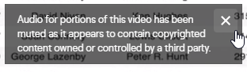

It is possible to [appeal such blocking](https://help.twitch.tv/s/article/how-to-appeal-flagged-content?language=en_US). Note that muted audio will also go into the recordings, so such sections are effectively lost if you don’t get the appeal sorted within the recording retention period.

* Streams are [only saved for 14 days](https://help.twitch.tv/s/article/video-on-demand?language=en_US) (60 days for paid accounts) and then only if you [enable VOD in your account](https://help.twitch.tv/s/article/video-on-demand?language=en_US):

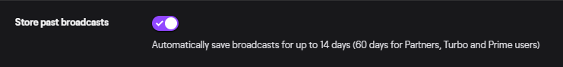

If recorded, you can download the streams after the event.

Note that it is possible to connect Twitch to a YouTube account and have it automatically upload recordings to a YouTube channel:

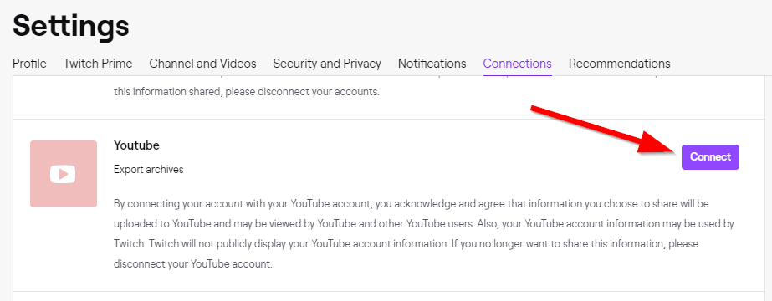

## Hopin

URL: <https://hopin.to/>

Features: <https://hopin.to/why>

User terms: <https://hopin.to/terms>

Organizer terms: <https://hopin.to/platform-terms>

Privacy: <https://hopin.to/privacy>

Knowledge Base: <https://support.hopin.to/en/>

Hopin is based in London, UK, which has some nice privacy implications. In particular, GDPR applies.

Support chat, polls and audio/video in a single web app. Also provides tools for a reception (waiting hall), stage, sessions, networking (hallway track) and expo (sponsors) inside the app.

According to [SatRDay](https://docs.google.com/document/d/1ZXmwVibQKtfCY_HiB49-OhQL-yKhUS9YD9yeMQZH88E/edit#), this would be a great platform for running online events, but currently still has some bugs (it’s still in early access mode). This comment was from our research in April 2020. In the meantime, things seem to have improved and a number of conferences have used Hopin for their event. The next one is [PyCon Turkey 2020](https://tr.pycon.org/).

*Apparently* you have to create an account with hopin.to in order to join a conference. At least that was the case for ApacheCon 2020. It could be an issue for some users:

* For some reason hopin.to is not available in their country (like Google in China)
* For whatever reason they do not want to create yet another account

Also it might be problematic for some conference organisers who do not want/can share attendee data.

The [IST 2020 Conference](http://ist2020.at) was using Hopin as their platform. They have published a [FAQ page](http://ist2020.at/hopin-faq/) on Hopin with a [guide for speakers, session chairs](https://www.youtube.com/watch?v=q8Uf1k8ZtTc) and general troubleshooting info.

Some salient pieces of information from their [FAQ page](http://ist2020.at/hopin-faq/):

* Please avoid any Brave, Safari, and Microsoft IE or Edge since these browsers lack the modern web technologies support necessary for online events to run in a web browser.
* Sometimes, third-party extensions can affect the experience blocking some of the Hopin interface elements. That’s why we also recommend opening the event in Incognito mode (command+Shift+N on macOS or Ctrl+Shift+N on Windows) on Chrome or Private tab (command+Shift+P for macOS or Ctrl+Shift+P for Windows) on Firefox.
* The Reception area is the welcome page or “lobby” of your event. Here you can quickly find out what’s happening at the event currently: the IST2020 welcome message, the schedule, and speakers. In the Reception area you’ll find announcements, important links and event updates.
* Stage: it’s a one-to-many interaction area that supports up to 100,000 concurrent viewers. The Stage will be used for the plenary sessions (keynotes, welcome and farewell, socializing).
* The Sessions segment of Hopin will be used for most sessions besides keynotes and IST Gallery content including full paper sessions, speed talk sessions and dialogue sessions. In Sessions, you will see virtual roundtables for speakers and attendees to interact. Up to 20 people can participate in a Session with their camera on, with up to 500 people who can watch off-camera and interact via the session chat. This is often where attendees ask questions to the speakers on camera.
* The Networking segment on Hopin is pure engagement and is similar to one-on-one meetings on a FaceTime call. This segment is designed to recreate the “coffee-in-the-lobby” conversations or watercooler chats that are important at an in-person event. The Networking area automates the discovery of new connections. When an attendee participates in the Networking, they are matched with a random attendee and meet for a set time preset by the organizer.

## BigBlueButton

URL: <https://bigbluebutton.org/>

Installation: <https://docs.bigbluebutton.org/2.2/install.html#bbb-installsh>

Open source system, mainly focusing on classroom style setups. Needs to be hosted on a rather beefy server or a pool of servers behind a load balancer (<https://github.com/blindsidenetworks/scalelite/tree/v1>) for larger audiences.

There are companies such as <https://blindsidenetworks.com/> who provide [hosting support for BigBlueButton](https://blindsidenetworks.com/hosting/). Prices are not readily available. <https://distancelearning.cloud/>

shows 300 Concurrent Users for 450 USD Month, there is a bunch of commercial supporters <https://bigbluebutton.org/commercial-support/>

## WebinarJam

URL: <https://home.webinarjam.com/>

Details: TBD

# Additional Tools

## Chat room tools to emulate the hallway track

### Telegram

URL: <https://telegram.org/>

We already use Telegram for most of the organization chats and also for attendees, so this would provide a natural environment for additional conference chats. TG does not support audio or video group chats, though.

2020-03-17: Registered a “europython-hallway” group on TG. Anders is admin as well.

### **Discord**

URL: <https://discordapp.com/>

Terms: <https://discordapp.com/terms>

Privacy: <https://discordapp.com/privacy>

Guidelines: <https://discordapp.com/guidelines>

Discord Nitro: <https://discordapp.com/nitro> (paid option which also supports live high quality audio and video streaming)

Discord Client downloads: <https://discordapp.com/download>

Runs in the browser (Chrome) or on Windows as an app. Has lots of fans in the gaming community.

Discord has a nice feature in that you can easily roll up your own “server” and then invite people over. This would allow making contact on the hallway chat and then wander off into other chat rooms for more specific topics.

Discord also allows video streaming, but only 10 people can join such streams (50 at the moment, due to COVID-19). On the plus side, those video streams are among the best when it comes to low latency, compared to other services. Audio-only channels are possible as well and can serve as e.g. talkback channels between track hosts and speakers during talks.

2020-03-14: Registered a EuroPython account and server on Discord.

#### Privacy concerns around Discord:

* <https://www.reddit.com/r/discordapp/comments/7a7vq3/discord_privacy_policy_shows_users_data/>
* <https://www.reddit.com/r/discordapp/comments/f63iyl/privacy_concerns/>

### **Jitsi**

Project URL: <https://jitsi.org/>

Free Jitsi Meet server: <https://meet.jit.si/>

Mobile client downloads: <https://jitsi.org/#download>

Jitsi Meet features: <https://jitsi.org/jitsi-meet/>

Jitsi FAQ: <https://desktop.jitsi.org/Documentation/FAQ>

Getting the Jitsi server code: <https://jitsi.org/downloads/>

Jitsi is an open source platform for video conferencing. You can run meetings using a public server or run your own. This is one of the easiest video conferencing platforms to get up and running.

It only requires a browser. Chromium based browsers work best. Firefox works as well, but sometimes has issues. Jitsi also comes with mobile apps to make this a little easier.

Jitsi supports streaming to YouTube, recording to Dropbox, has features such as raising hand, screensharing, chat and setting a password on the rooms.

**Important note**: It is advised to use a password on the rooms to prevent “Zoombombing”. Do note that the passwords do not persist when the last person leaves a room, so it has to be set by whoever creates (or recreates) the room by joining it.

#### Hosting your own Jitsi Meet server

If the managed server <https://meet.jit.si/> is not reliable enough, you can host Jitsi on your own infrastructure (e.g. a root server) as well.

These are a few guides:

* [Jitsi meet quick install](https://github.com/jitsi/jitsi-meet/blob/master/doc/quick-install.md) on your own server
* [Jitsi meet Docker install](https://github.com/jitsi/docker-jitsi-meet/blob/master/README.md)
* [Setup Jitsi in less than 15 minutes](https://www.brring.com/2020/04/04/setting-up-a-jitsi-server-in-less-than-15-minutes/)
* [Video tutorial on setting up a Jitsi server](https://jitsi.org/blog/new-tutorial-installing-jitsi-meet-on-your-own-linux-server/)
* [Setting up Jitsi on Ubuntu 18.04 LTS](https://jitsi.org/blog/new-tutorial-installing-jitsi-meet-on-your-own-linux-server/)
* [Setting up Jitsi with authentication](https://dev.to/noandrea/self-hosted-jitsi-server-with-authentication-ie7)
* … there are plenty more on the net.

Overall, it’s not too hard to do, but you need some skills in setting up servers, domains and network stacks. The [manual installation guide](https://github.com/jitsi/jitsi-meet/blob/master/doc/manual-install.md) has full details. The [scalability guide](https://github.com/jitsi/jitsi-meet/blob/master/doc/scalable-installation.md) provides an overview of the Jitsi meet architecture.

In terms of hardware or VM, Jitsi needs fairly powerful servers with excellent network connectivity. The technology is divided in a host server and bridges which handle the in-meeting traffic. The meet.jit.si installation apparently uses [c5.large AWS instances for the bridges](https://community.jitsi.org/t/hardware-needed-for-jitsi-server/14289). They recommend a 4 CPU, 8 GB machine for the host and 4 or 8 CPU VMs with 8 GB RAM for the bridges.

#### Experience

Marc: It is said to work with up to a few hundred users. I have tried with 6 devices and it works great.

The only downsides I noticed are:

* Mobiles get pretty warm after a while, so the app seems to use lots of resources
* Feedback noise is not well filtered
* It can use around 10% CPU time in video chat mode with multiple participants per tab.

On the plus side:

* Echo isn’t much of a problem anymore as it was some years ago
* Connecting using Chrome or Firefox is really easy; there’s next to no setup needed (except for setting the right video and audio devices)
* Jitsi has some limited moderation tools (e.g. mute others, kick/invite participants, etc.)

Jitsi also supports streaming to YouTube and recording to Dropbox.

Martin: Jitsi works well for video casts, but in larger meetings the lag in screen sharing kills any live coding or faster slide flipping.

Marc: Our Python user group is currently (weekend 2020-03-28/29) running a small sprint (6-8 people) using Jitsi and Telegram as chat. Works well so far, but Jitsi does disconnect every now and then reconnects, without persisting the settings that were configured for the chat room, so not really usable for larger setups. It works best with Chrome. We saw a few hangs and crashes in Firefox. Also, we are seeing similar lags in screencasts as the ones Martin had reported, typically around 2-3 seconds.

Alex: We deployed it in one medium sized instance and had a meeting with 5 people. The instance reached 90% CPU usage. One person even got kicked out. Scaling such a setup is a problem. 8x8, the company behind Jitsi, told Alex that Jitsi can only handle up to 50 people in the same call, so it’s not usable for webinar style meetings.

### Slack

URL: <https://slack.com/intl/en-de/>

Pricing: <https://slack.com/intl/en-de/pricing>

Last time we asked, they would not accept the EuroPython Society asa non-profit, so we would not be able to get non-profit pricing.

Slack provides chats, grouped in channels, much like Telegram does as well.

The free plan does not support group video/audio chats. The standard plan does, but only up to 15 participants: EUR 7.50 per person and month.

### Mattermost

URL: <https://mattermost.com/>

Pricing for hosted version: <https://mattermost.com/pricing/> (non-profit pricing available as well)

Mattermost is an open source clone of Slack. It can be self-hosted, but it’s also possible to get a hosted installation.

#### Experience

Marc: We tried Mattermost for EuroPython in 2017, but then turned to Telegram for chat instead, since the mobile apps and desktop clients were not really good enough at the time. Things will probably have changed a lot by now. The installation is still around on our server, but hopelessly out of date.

### Riot Messenger / Matrix.org

URL: <https://about.riot.im/>

Messenger running on the [matrix.org](https://www.matrix.org/) network protocol.

This is a rather complex chat system, which supports rooms, one-to-one chats and communities. Setting up our own server would be possible, but is a lot of work. Matrix.org provides a free one.

Audio/video chat may be available, but requires use of a 3rd party integration server. Encryption is supported as well, but requires a complex verification process, which is not really suitable for everyday use.

#### Experience

Marc: We tried a setup of Matrix.org in our user group sprint in March 2020. The setup took more than a day to figure out. The docker setup was very difficult to get running and we eventually gave up and instead turned to the pip install method. Configuration is highly complex, since there are way too many parameters to consider. Given that it’s a server application, this doesn’t give you a good feeling about server safety. The client (Riot) looks good, but is so stuffed with features that it’s difficult to use. End-to-end encryption is available, but again, not something you’d want to have to explain to your users -- the process for verifying keys is just too much of a hassle.

### StreamYard

URL: <https://streamyard.com/>

Tools for streaming to YouTube.

Supports up to 6 participants, but unlimited viewers via YouTube.

### Mozilla Hubs

URL: <https://hubs.mozilla.com/>

Docs: <https://hubs.mozilla.com/docs/welcome.html>

Hosting events in Hubs: <https://hubs.mozilla.com/docs/intro-events.html>

This is a fairly new Mozilla project to run meetings in a VR environment which you can create yourself using [Spoke](https://hubs.mozilla.com/spoke), or you can choose from their [example scenes](https://hubs.mozilla.com/docs/intro-events.html#choosing-a-scene). It allows interacting with 3D objects, playing video content or showing PDFs in the virtual rooms.

Rooms are (currently) limited to 24 people. There is an integration with Discord ([HubsBot](https://hubs.mozilla.com/docs/hubs-discord-bot.html)).

For larger events, you can setup your own Hubs installation on AWS using [Hubs Cloud](https://hubs.mozilla.com/docs/hubs-cloud-intro.html).

## Streaming and Webcam Tools

These are tools which can be used by meeting hosts or (experienced) speakers for sharing content. They are often difficult to setup or to use, so not necessarily an option to use as standard setup for speakers.

### OBS - Open Broadcaster Software

URL: <https://obsproject.com/>

This is an open source tool which provides great live mixing, scene and staging tools for streaming sessions on a single PC/notebook.

It can stream directly to YouTube, Twitch and a large number of other services.

For streaming to online conference systems, it is usually best to use either a virtual webcam solution such as [OBS VirtualCam](https://obsproject.com/forum/resources/obs-virtualcam.539/) or have OBS output the mix to a projector which is then captured using screen sharing.

OBS can be used to stream sessions to e.g. YouTube in case the online conference system does not support this directly out of the box.

#### Note for Zoom users on Windows

##### Feeding Zoom from OBS using the VirtualCam plugin

It’s possible to use [OBS](https://obsproject.com/) together with [OBS VirtualCam](https://obsproject.com/forum/resources/obs-virtualcam.949/) to prepare the video feed for Zoom, but only if you use the latest versions of Zoom (>= 5.0), OBS (>= 25) and VirtualCam (>= 2.5). This works with both the 32-bit and the 64-bit version of OBS.

Previous versions of Zoom (4.6.8 - 4.6.10) on Windows did not accept the VirtualCam output as input: <https://github.com/CatxFish/obs-virtual-cam/issues/78>. If you had one of these versions installed, it’s possible that you have to uninstall Zoom and then reinstall a 5.0+ version again, to make things work.

Unfortunately, it seems that Zoom limits the webcam resolution when sharing it in online sessions, so such a setup only makes sense for content which doesn’t need high resolution (e.g. screen sharing doesn’t really work in this mode). See this [bug report](https://obsproject.com/forum/threads/obs-virtual-cam-output-is-blury-and-pixelish.118650/page-3#post-450131) for more details.

Example:

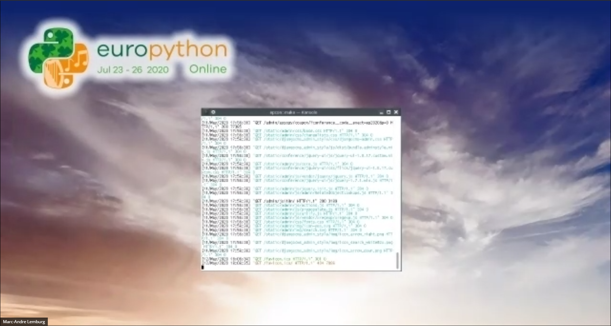

Be sure to select “Enable HD” in the Zoom client options to at least get better quality video:

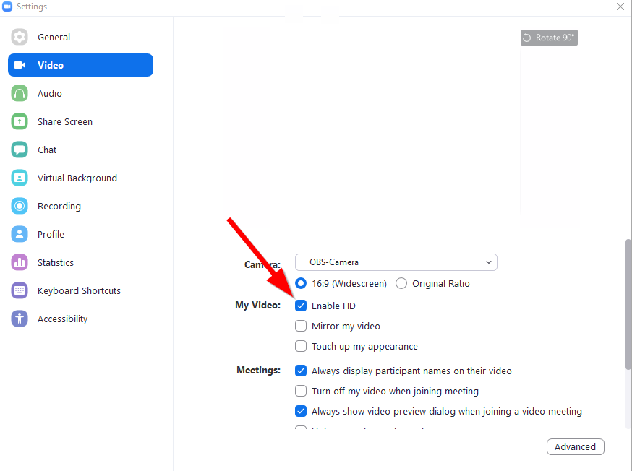

##### Feeding Zoom from OBS using a projector screenshare

A better option is to have OBS output a preview using a “Fullscreen Projector”, which you then screen share using Zoom. This only works if you happen to have a spare screen around. Using the “Windowed Projector” also works, but causes issues when the window is minimized or covered by other windows - Zoom will then pause the screen sharing until you clear up the window again.

You can switch on the “Fullscreen Projector” by right-clicking into the OBS preview window and selecting the monitor you want to use for the preview:

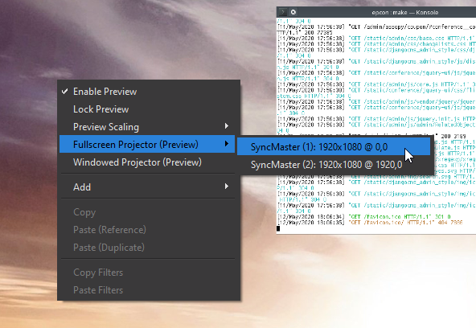

This will give you almost full HD resolution, but screen updates will slow down a lot, so if you are using a webcam or showing video using OBS, the experience will not be the greatest. It kind of works for small webcam thumbnails of the speaker.

If you turn on the “Optimize Screen Sharing for Video Clip” in Zoom’s sharing dialog, you will get more FPS, but the resolution will go back to something close to 360p, essentially the same as with the virtual webcam approach:



It’s also not possible to turn this option on / off while screen sharing, so if you want to use this only temporarily, you have to start a new share every time.

### Webcamoi

URL: <https://webcamoid.github.io/>

Another tool to mix and match webcam and other input to output to a virtual webcam, which can then be shared using online conference tools.

### Streamlabs

URL: <https://streamlabs.com/>

All-in-one streaming tool. Built on top of OBS, with an emphasis on simplicity and auto-configuration.

### Virtual Audio Cable

URL: <https://www.vb-audio.com/Cable/index.htm>

This is useful if you want to send audio from an application into Zoom, Jitsi or any other application taking microphone audio input and greatly increases your flexibility when it comes to adding audio feed such as e.g. applause, sound effects, etc. to the stream as host.

Available for Windows as donation ware. They also have a complete mixer set with multiple such cables as [Voicemeeter Potato product](https://www.vb-audio.com/Voicemeeter/potato.htm).

### Virtual DJ

URL: <https://www.virtualdj.com/products/virtualdj/>

If you want even more flexibility in audio mixing, this is a solution which also provides virtual audio cables, but in addition comes with a complete DJ mixing console.

### Cadence (JACK2 linux)

URL: <https://kx.studio/Applications:Cadence>

Using Cadence is easy to get JACK working together with pulseaudio and then you can use “Claudia” to patch different sources to different outputs and save the configuration.

The Archlinux wiki has good resources on how to get it working <https://wiki.archlinux.org/index.php/PulseAudio/Examples#PulseAudio_through_JACK>

For mixing I used [jack_mixer](https://github.com/relascope/jack_mixer)

Example:

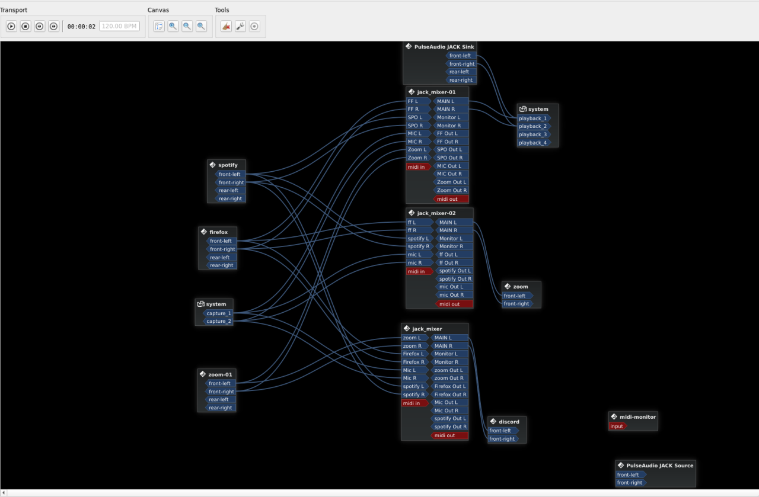

It’s possible to patch different sources of audio to different outputs and also mix them

### qjackctl + pulseaudio-module-jack

An alternative way to Cadence on Linux for using jack to mix in applause sounds is to use qjackctl and the pulseaudio-module-jack to talk to pulse.

1. install qjackctl pulseaudio-module-jack
2. Open qjackctl, go to Setup… > Options > Execute script after Startup, and put the command there: pacmd set-default-sink jack_out
3. Click start on the qjackctl, then the Connections should be made immediately, like this:   
   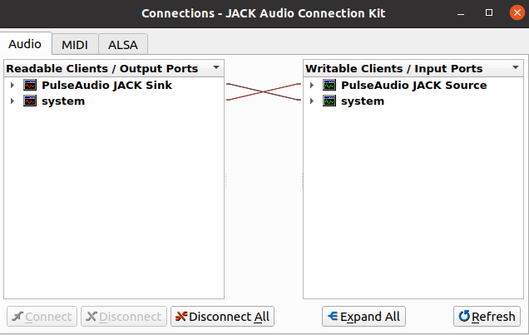
4. In your system sound settings, make sure both the Speaker and the Microphone have now selected Jack Sink (PulseAudio Jack Source)
5. Then play your applause file through jack, for example, if you are using mpv as a player, it’d be mpv -ao jack filename; you will now notice on your Jack Audio Connection Kit that the player (mpv) appears as a jack sink. Simply make the connections from mpv to Pulseaudio Jack Source, and you should be able to mix in the sound from the file now:  
   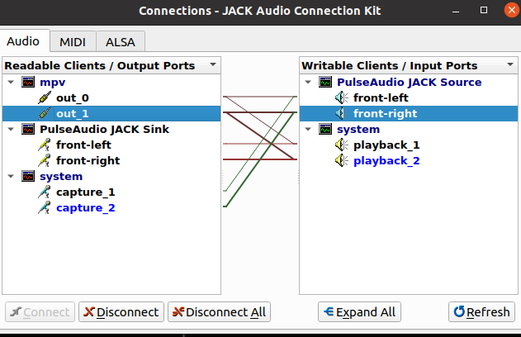
6. For more detailed info on, including tips on xruns, please check out a user’s documentation: <https://docs.google.com/document/d/157pn9INUse4L_rcq9Jt-biI3v0njliRcp5Fj2rTK17c/>

### Jamulus - Online Jam Session Software

URL: <http://llcon.sourceforge.net/>

Github: <https://github.com/corrados/jamulus>

Wiki: <https://github.com/corrados/jamulus/wiki>

If you want to have multiple musicians play together over the Internet, latency and delays of typical conference tools, which are optimized for speech, quickly become an issue. Jamulus tries to address this by providing a direct low latency link between the musicians.

The mix can then be streamed to conference tools via computer audio sharing.

The software is available for Windows (via ASIO), macOS and Linux (via JACK). It requires a set of clients and a server which ideally is close to the clients.

Jamulus [synchronizes the input from the jamming musicians and produces a mixed signal](http://llcon.sourceforge.net/PerformingBandRehearsalsontheInternetWithJamulus.pdf) which it then passes back to the players. There may be slight delays between what they play and what they hear as a result and they should thus wear headphones to isolate the instrument sounds from what the server returns as mixed signal.

### JamKazam - Online Jam Session Service/Software

URL: <https://www.jamkazam.com/products/platform>

JamKazam is a freemium software and service which provides a platform to play together over the Internet. The basic service is free. [Premium accounts](https://www.jamkazam.com/corp/premium_accounts) are available for additional features.

### Jammr - Online Jam Session Service/Software

URL: <https://jammr.net/>

Jammr is another freemium platform for playing together over the Internet. Jammr is live, but [not real-time](https://jammr.net/howitworks.html), yet it still gives the impression of playing together by synchronizing on chord progressions.

## Support Tools

### Zammad Helpdesk

URL: <https://zammad.org/>

This is not specific to the online setup, as EuroPython has been using a helpdesk for many years. Earlier this year, we switched from Django Helpdesk to Zammad Helpdesk and have been very happy with the result, though at times, some WG members have said the UI is a bit confusing.

Our setup includes different queues, each usually reflecting the works of different WGs, and each points to a different email address, as the following:

*EuroPython Helpdesk / Support WG:* handles generic questions and functions as a triage to move the question to the right queue and person, if necessary.

*EuroPython Program Helpdesk / Program WG:* scheduling, speaker contact, speaker requests, and talk cancellations or modifications, sending out speaker coupons. Will often need to coordinate closely with the support team.

*EuroPython Refunds / Treasurer and Support WG:* all refund requests should be moved here to be processed later by the Treasurer.

*EuroPython Financial Aid / Financial Aid WG:* deals with all financial aid questions and handles the whole logistics of Financial Aid grants.

*EuroPython Sponsor Helpdesk / Sponsor WG:* collects the assets current sponsors need to turn in, job recruitment, blog posts, tweet submissions, etc

Some of the things we like about Zammad:

1. Notification: every agent in a queue can be notified by email when there is a new ticket or state change. They can also configure their own notification.
2. When a user replies to a ticket, even if they remove/edit the original email subject completely, it still wouldn’t spawn a new ticket.
3. Auto saves response/state. When the agent writes a draft, log in from another device, they can still go back to the previous state.
4. When a user replies to a closed ticket, the ticket automatically gets reopened.
5. For an admin, one can view from the perspective of any user.
6. Splitting and merging tickets are a very useful add-on and very easily achieved.
7. Can create templates (called text module), and can use variables in the template, e.g. #{ticket.customer.firstname}. Very useful for repetitive questions.
8. When a ticket is marked as spam, the user will no longer have permission to access the ticket via the web interface.
9. Agents could have internal discussions (notes) without the user having access to it. This can allow a bit of chat between agents to come up with a resolution. One thing to look out for is by default, “enter answer” is an internal note. To reply to the user, the agent needs to click “reply to”. Protip: “Internal” messages are outlined with a salmon border, and can only be viewed by other agents. See the documentation for a more detailed explanation.
10. Triggers and API for automation and integration.
11. Can create and select tags. Searching for all tickets with a same tag and get a count can be quite useful.

# Other Resources

* [Humboldt-Universität zu Berlin: Digitale Konferenzen](https://www.projekte.hu-berlin.de/de/gnuHU/anleitungen/digitale-konferenzen/) (in German)

Focuses on just using OSS tools

* [Start-to-Finish Techniques Regarding the Practicalities of Producing Purposeful and Impactful Webinars](https://www.joe.org/joe/2018october/tt2.php)  
  Explains the webinar setup they use. Esp. the table 2 summary of fixes to common problems is useful.
* [Virtual Conferences - A Guide to Best Practices](https://docs.google.com/document/d/1XsGDOHzBhY9S-D4Smp2p9JgqdI0umZ0IZVi7Nhm0gYg/edit#) by the ACM Presidential Task Force

Includes some interesting notes on aspects such as [dealing with different time zones](https://docs.google.com/document/d/1XsGDOHzBhY9S-D4Smp2p9JgqdI0umZ0IZVi7Nhm0gYg/edit#heading=h.yirojjlfo3et) and also highlights organizational aspects such as [how many people you need](https://docs.google.com/document/d/1XsGDOHzBhY9S-D4Smp2p9JgqdI0umZ0IZVi7Nhm0gYg/edit#heading=h.8ym8j06clkxm) to run sessions.

* [Series: You're Doing Virtual Events Wrong! Advice from the Community: Attendee Experience](https://dev.to/tessamero/series-you-re-doing-virtual-events-wrong-advice-from-the-community-attendee-experience-2p02)

Post collecting attendee feedback on virtual conferences.

# Common problems with conference tools

## Poor sound from speaker

In many cases, this is due to speakers using built-in notebook audio to run the session. Apart from a lot of background noise, this often also adds fan noises, keyboard clapping and dampens the sound.

It’s best to have speakers use proper headphones to work around all these issues. Some headphones provide background noise cancellation, which makes the experience even better.

If sound is breaking, this can be caused by the tool using noise or feedback cancellation. The speaker should then turn down the volume of the audio output on his/her side. Another cause could be the Internet connection. In that case, trying a mobile or dial-in connection usually helps.

It is also worth mentioning that speakers should try not to have background noise in the room they are running the session, i.e. no music playing, espresso machine or dishwasher running, etc.

## Poor video from speaker

If video frequently freezes, becomes blurry or lags, it’s likely that the upstream connection of the speaker is not capable enough to provide the necessary bandwidth. In such a case, it’s often better to switch off video and focus on the audio part.

Another cause for poor video is heavy load on the notebook/PC the speaker uses to host the session. If the presentation involves CPU heavy demos, it’s better to run the audio/video hosting from a second notebook, tablet or mobile.

Also important is to have the speaker setup lighting in a way which reduces highlights, reflections or strong contrast. The best way to achieve this is by using bright indirect light in the room.

## Stressed speakers

Running an online session can be stressful for the speaker due to the many moving parts in such a setup.

It is usually a good idea to have a rehearsal session before the talk to make sure that the setup is working correctly, e.g. by having the speaker join 20 minutes before the session starts and then stay online to avoid having to repeat the setup.

It’s also a good idea to have the speaker stay focused on the talk. Speakers should try not to follow the chat or the Q&A. A moderator should take this load off of them, so they can focus on answering questions.

Another possibility to reduce stress is turning off video and only running the talk using screensharing and audio.

## Hijacking online sessions

Many conference systems just use single links to connect to a session, usually with a single number or short text identifying the session.

Since such links can easily be shared, the “hidden” information needed to join a meeting can easily get into the wrong hands. Purely number based solutions are also subject to enumeration hacks (e.g. Zoom, Skype for Business, GotoMeeting, etc.)..

Where possible, the online sessions should be protected using passwords or even have the host select the participants who can join via a gateway logic such as a waiting room. The latter is difficult to do for larger audiences, of course.

Here’s a tool which shows how easy it is to hijack a Zoom session without password:

* <https://krebsonsecurity.com/2020/04/war-dialing-tool-exposes-zooms-password-problems/>

## Need for chat moderation

Chats in these tools can be subject to the usual trolling you see around the Internet a lot these days.

A moderator should try to keep an eye on the chats, attempt to reduce the noise or simply kick participants who do not play along well.

It is also important to use tools which allow deletion of chat messages. Zoom chat, for example, does not allow this and so the poor commentary stays in the chat even after the spammer has been kicked.

## Don’t allow anonymous attendee contributions

Spammers will typically try to stay anonymous, either by using false names or by contributing their “comments” using anonymous settings of the chat or Q&A tools.

In order to act quickly, the tools should be set up to at least not allow for anonymous Q&A or chat subscriptions. The moderators then have a more direct way to kick those spammers quickly and effectively.

# Common hints

## Only show the speaker video while in a talk

It is rather distracting for attendees to see more than one video feed during a talk. All concentration should be on the speaker and not also on other panelists or the moderators.

That said, it’s a good idea to show all panelists between talks, since this gives a better idea of how many people are involved.

## Running a Q&A session

At an in-person event, you usually have mikes setup for attendees to ask questions. For online events, the same can be done using chat, but is less engaging.

If possible, try to use a “raise hand” feature in the tool to give audio permission to attendees to ask questions via audio and have the speaker answer them via audio as well.

Where this is not possible, Q&A tools provide a good and organized way for having attendees ask questions via text. A moderator should then read out the questions. Speakers can then answer via audio.

Using just chat for asking questions is difficult if you have lots of people in the virtual room. A moderator will have to collect them and manage these live in a similar way as mentioned above for the Q&A tool.

Having the speaker take care of the Q&A moderation is possible, but normally not advised to keep them focused on the topic rather than the tooling.

## Running a lightning talk session

A bit unexpected, this works really well in an online setup.

You setup a Google sheet for attendees to register their talk titles, topic and name. Promote this throughout the day or session and then, when it comes to lightning talks, you follow the order in the sheet, making all speakers panelists before starting the session, so that switch over is fast.

Do remember to stick to the 5 minute limit per talk.

Note that some tools only allow one person to share the screen, so sharing has to be moderated. Sometimes starting screensharing can also cause a short drop in audio / video.

# Hints for specific tools

This is a collection of hints we found while researching the different tools.

## Zoom

The system has a gazillion options and settings, so it’s easy to miss a few features. Their [help system](https://support.zoom.us/hc/en-us) provides more information on the various settings.

### Webinar roles

This Zoom help page summarizes the different roles: <https://support.zoom.us/hc/en-us/articles/360000252726>

* **Hosts** can setup the meeting and control it
* **Co-hosts** can help with hosting, but don’t have full control
* **Panelists** can provide content and have their webcams visible in the chat.
* **Attendees** can only listen in the webinar. The host/co-host can unmute them individually to e.g. ask questions.

Only the host can control streaming to YouTube. Host and Co-host can record locally as a backup.

### Non-verbal feedback

This can be enabled in the account settings under “**Nonverbal feedback**” and results in the attendees seeing buttons:



at the bottom of the participant fly-out.

Clicking on the buttons gives feedback to the host in form of summary numbers:

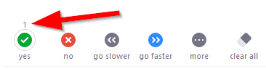

### Keep the Zoom meeting window open when screen sharing

Normally, Zoom closes the meeting window when you start to screen share. This makes it difficult to administer a session at times (but makes sense if you only have a single screen).

There is an account setting “**Show Zoom windows during screen share**” to keep the window in view.

### Moving the screen sharing bar out of view

The sharing tools are always displayed at the top of the screen you are sharing:



When doing full screen sharing, the bar often gets in the way and what’s worse: the audience will see the bar as well.

Fortunately, the bar can be moved to a different screen or position: you have to hover and click-hold into the green part of the bar to enable dragging.

Alternatively, you can hide the bar via “Alt-Ctrl-Shift H”.

### Sharing browser windows without showing the location bar / hiding sensitive data

You sometimes want to share a browser window, but don’t want to expose the URL of the page you are showing to the world (eg. for Google Docs that are editable with the link). Or you may want to only show part of a window or desktop, without revealing other sensitive data.

Zoom normally only allows sharing whole desktops or complete windows, but there’s also a somewhat hidden feature to only share a desktop area, which can be used for the above purpose.

When entering the screen sharing dialog, click on “**Advanced**” and then select “**Portion of the Screen**”:

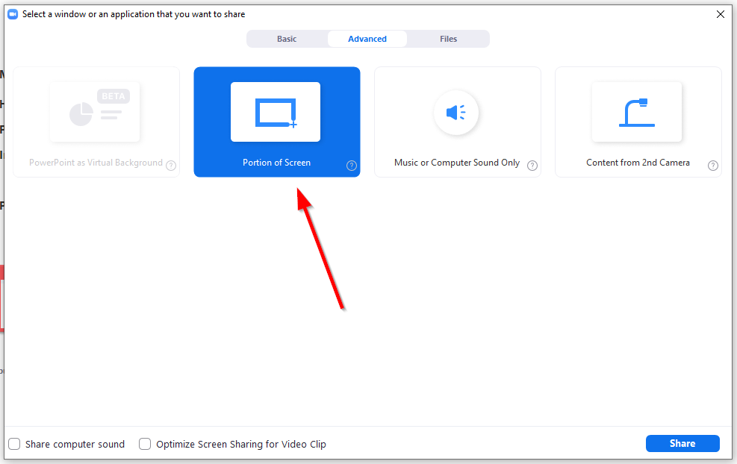

Once you click on “**Share**”, a green rectangle will appear, which allows you to define the portion of the screen to share.

***Warning***: Sharing starts immediately, so this may still reveal information you don’t want to go into the Zoom recording or into the YouTube.live stream, if the rectangle happens to be set to an area which exposes this.

Fortunately, Zoom remembers the last selected region, so you can adjust the rectangle prior to the meeting, e.g. in a separate personal meeting, and then adjust the rectangle to only show the browser tab content without the bookmarks and location bar.

### Ending a meeting when in screen sharing mode

If you are sharing your screen and don’t have the meeting window in view (which has the “End Meeting” link at the bottom), you can end the meeting by hitting “Alt Q”.

### Joining via browser link not showing for participants

Zoom defaults to not showing this initially. To enable it, turn on the account setting “**Show a "Join from your browser" link**”

The URL for the browser start is similar to the regular URL for Zoom meetings:

https://zoom.us/wc/<room-id>/start

### Joining using a web browser appears to require having a Zoom login

Note that joining from the Zoom client application always requires a Zoom login.

Using the browser, this was originally not the case, however, there appears to be a new account setting, which is enabled by default:

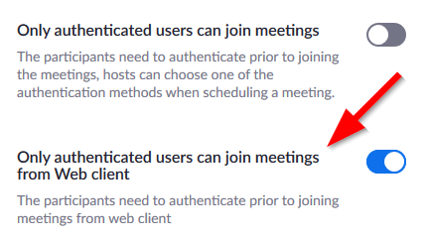

Disabling this will again allow users to login using a web browser with just the link and the password.

The user will still have to accept the Zoom terms and privacy:

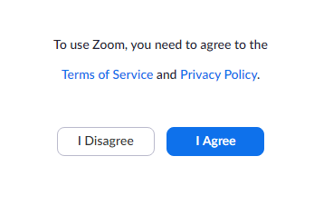

Once agreed, the user will have to enter a name and then the Zoom meeting opens.

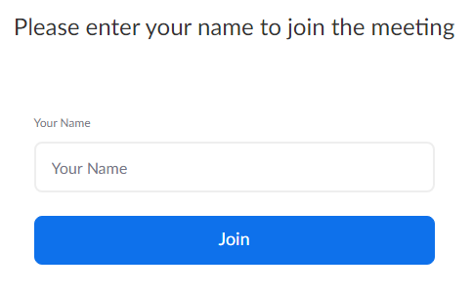

Note: The above is true for regular Zoom meetings. For Zoom Webinars, users will additionally have to enter an email address.

### Join from browser interrupted by cookies consent

If **Only authenticated users can join meetings from Web client** is disalbed, as illustrated above, user with the right URL and password (either with registration required or not) will first be directed to a Accept Cookies page:

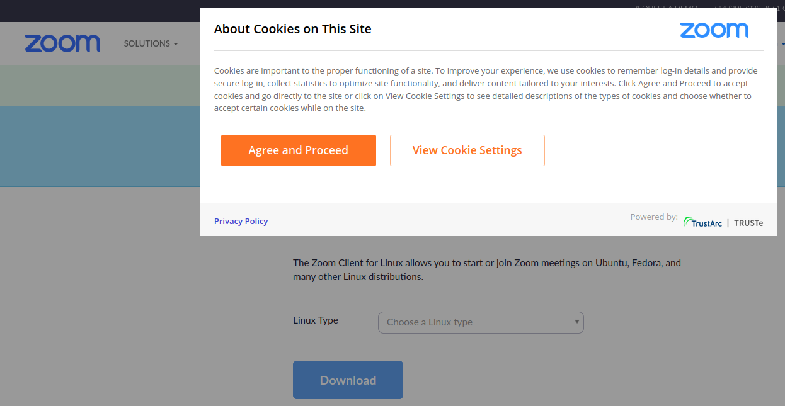

After updating the Cookie settings, the page will not redirect to the webinar link. Instead, it stays at <https://zoom.us/download>. The user will need to copy the URL again and load the page. This can be confusing as it might give the users the impression that they will need to download the Zoom application in order to participate.

Update: doesn’t seem to be a problem on chrome. The Cookies banner disappears after a few seconds without even clicking ‘agree’.

### Webinar Topic

Each webinar session has a topic the attendee can see from the browser:



This is not viewable in full screen mode.

That means we might have two ways to name the topics:

1. By track, e.g. Track 1, 2, 3 (Good sponsorship options)
2. The host for the track will manually change the topic into the next talk. But as there is no live update for this, the host will need to end the meeting first and rejoin. Fortunately, the URL+Password will not need to change.

### Join via dial-in

When the user join the call, they can also select to see the local dial-in number:

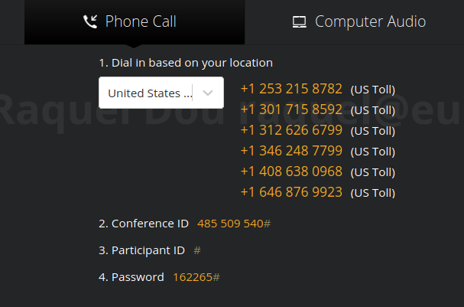

After keying in the conference ID and password, they will show up as an attendee. They can be unmuted to talk. But they cannot be promoted to a panelist. The number they used to call will show up to the hosts (and possibly the panelists):

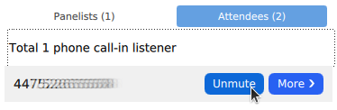

However, if the caller hides their caller ID, it will show up as Call-in User_No:

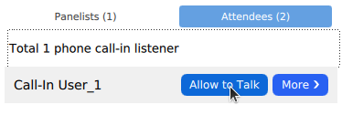

Alternative to seeing the dial-in number from the webinar link, we can also preselect a list of countries to include in the email template. This is done from Edit Webinar -> Audio -> Dial from X Edit. Then Selected the desired countries:

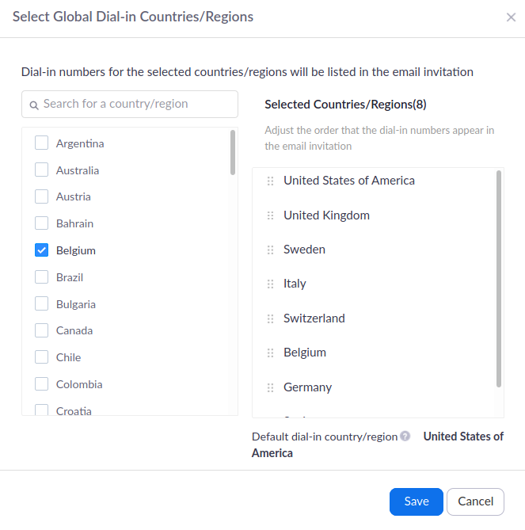

Then these numbers will show in the email confirmation upon successful registration.

Lastly, all international numbers can be found: <https://zoom.us/zoomconference> but only paid accounts can see most of these numbers, so it is still good to go with the last two methods.

This can be a last resort backup plan for the speaker who loses internet connection and has no mobile internet backup.

### Registration Settings

Registration settings can be globally set from <https://zoom.us/account/webinar/setting> -> Registration Settings:

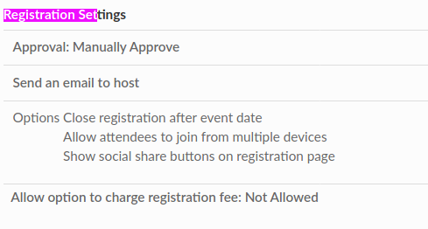

However, this will not override existing webinar settings if they are different. Only newly scheduled webinars will have the global registration setting as default.

### Require Registration Details

If registration is set to Required, each participant who register will get a URL with the tk= part being unique: <https://zoom.us/w/webinarCode?tk=uniqueCode&pwd=webinarPassword&uuid=webinarUUID>

However, if authentication is not set, i.e. no login is required, anyone with the link can still view the webinar.

While the webinar is ongoing

* the host can only see the names of the attendees. No way to see the unique code sent to them associated with the name.
* [Report](https://zoom.us/account/report/webinar) is not available during the webinar.

After the webinar, [Report](https://zoom.us/account/report/webinar) can be obtained. But it is quite limited. If we have users doing a mass share, this will not be easy to manage, particularly during the webinar. Especially considering we might not end the webinar session during the entire conference day, it would be particularly challenging.

Screenshot of Attendee Details part of the report:

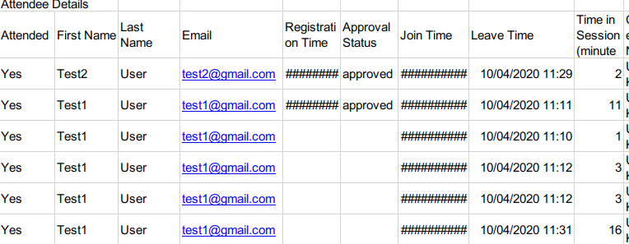

### Chat and Q&A history does not persist

If one rejoins, they will not see any history. We should have important links and Q&A stored somewhere else. And maybe disable chat altogether so everything will persist on discord.

### Cannot moderate/remove chat

If a message is offensive, the host can ban the messenger but cannot remove the offensive chat. This is a good reason to move chat out of Zoom.

### Poll does not show up if the participant joins before the host

If the participant is put into the waiting room before the host joins/broadcasts the session, then they will not see the poll at the beginning of the session. Rejoining the session will fix that.

### Temporary freezing or drops

* When the presenter starts to share their screen, we often see the video freezes for a few seconds. We can ask the presenter to verbally confirm with the host that everything is good before proceeding to present.
* Live coding is generally responsive. But if the code is heavy running on the same machine, we do see AV delay or video framedrops. It is much better if the code is run on a remote machine.

### Allow removed participants to rejoin logic

Ideally, we should disable this so that we kick someone out due to violation of CoC or T&C, they cannot keep rejoining and causing further trouble. This is set to off by default from Person->Settings->In Meeting (Basic): 

However, in the case of the speaker having everything frozen and thus having trouble leaving the meeting themselves, the host might choose to kick them out. Afterwards, the speaker will not be able to rejoin using the same account.

### Alternative Host

[**Alternative hosts**](https://support.zoom.us/hc/en-us/articles/208220166): Shares the same controls as co-hosts, but can also start the meeting. Hosts can assign alternative hosts when they schedule a meeting. However, the alternative host must be a licenced Zoom user. When trying to assign to an unlicensed user (basic free account), you get an error message: {{email}} is not associated with a Zoom account. This does not mean they do not have a zoom account, just that they have a free one.

### Co-hosts

One session can have multiple co-hosts. But these can only be done in-meeting, unlike alternative hosts. This can be enabled from Account Settings -> In Meeting (Basic):

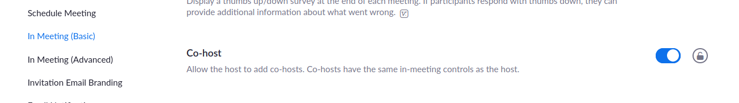

To promote an attendee to a co-host, we need to first promote them to a panelist. Then we can choose to make them a co-host. As of now, 4 co-hosts in a session have been tested.

### Joining multiple Zoom sessions

When a user is logged in, Zoom will prevent them from joining a different session. This can be problematic if they are logged in:

1. The attendees will have to choose to end the webinar before switching to the breakout Zoom Room. This is not too bad as they can simply rejoin.

2. The co-host will have to choose to end the webinar. This is more serious. When they rejoin the webinar, they will have to be promoted to panelist then co-host again. Because of this potential interruption, **uninterrupted recording should NOT rely on them.**

3. If we want people to mod multiple sessions, they will need to get the session link and run in the browser without logging in.

Screenshot for attempting multiple sessions from the app:

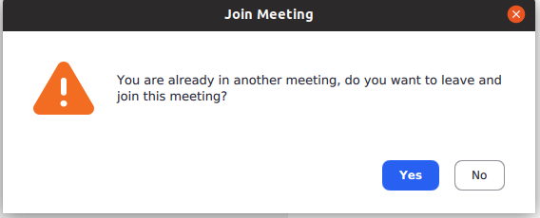

From the browser:

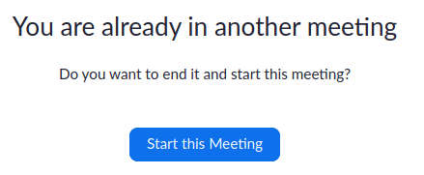

I have also tried to both Start and Join a Zoom meeting (with a basic free account) from the browser while a webinar is on-going (started from the Zoom app). On Firefox, the “start from browser” does not show up. On Chrome, it does, but then it is redirected to a sign-in page after clicking it.

### Enabling Video Streaming to YouTube

Even though Zoom provides a way to do ad-hoc streaming to YouTube, it’s better to prepare this first and setup a live streaming on YouTube before the Zoom meeting or webinar.

#### Set up the YouTube stream

* Go to your YouTube account and into the streaming dashboard: https://studio.youtube.com/channel/<channel-id>/livestreaming/dashboard
* Click on the “Live” icon on the left
* This will open the “New stream” popup:

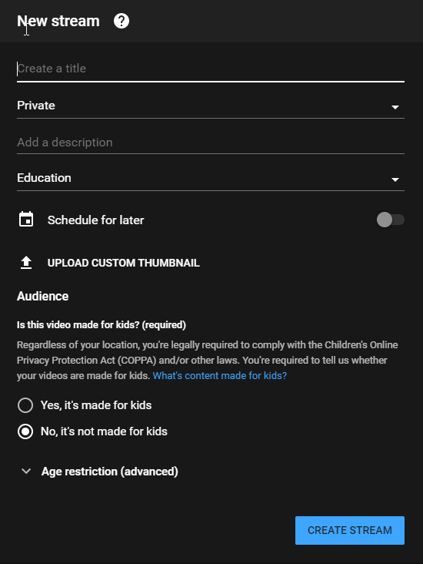

Enter a title and set a thumbnail (this should be a 1920x1080px image).

Adjust the “Private” setting as necessary. “Private” will not make the video available to anyone, except people you explicitly share it with. “Unlisted” will have the video become visible by anyone who knows the link, but it will not appear in YouTube searches or on your channel. “Public” makes the stream public, searchable and also has it appear on your channel. These settings can later be adjusted for the recorded video, if necessary.

Leave the audience set to defaults. **It’s important to not configure the stream as appropriate for kids** (even though it may well be), since YouTube bots can then easily disable your stream halfway through. It’s always possible to re-enable this later on on the cut videos. For more details, see the [YouTube help page on this](https://support.google.com/youtube/answer/9528076) and [their FAQ on the topic](https://support.google.com/youtube/answer/9684541?hl=en).

Aside: You can disable the kids audience setting at the YouTube account level as well, under Settings / Advanced Settings:

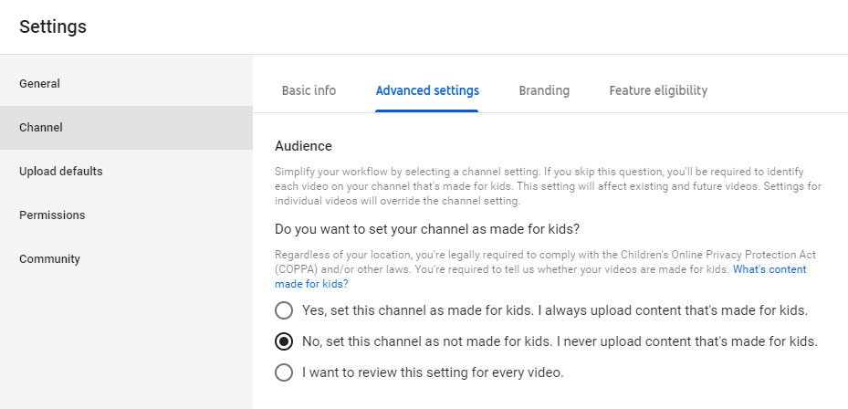

Finally, click “Create stream”.

* Next, the stream config panel opens:

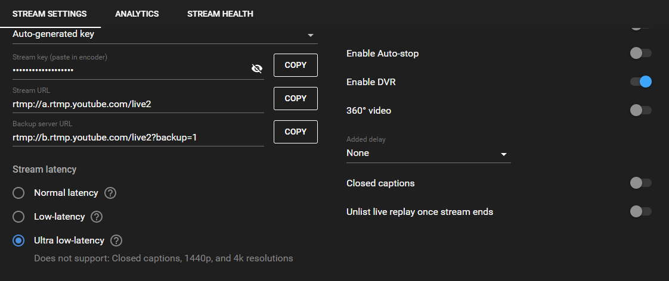

For live presentation streams, it’s best to use “Low latency” or “Ultra low latency”.

You should also enable DVR to keep a recording of the stream on your YouTube account.

#### Configure Zoom to stream to a custom stream service

* For regular Zoom meetings, you have to [enable the custom streaming option](https://support.zoom.us/hc/en-us/articles/115001777826-Live-Streaming-Meetings-or-Webinars-Using-a-Custom-Service) under “Admin / Account Management / Account Settings / Meeting” near the bottom of the page:  
  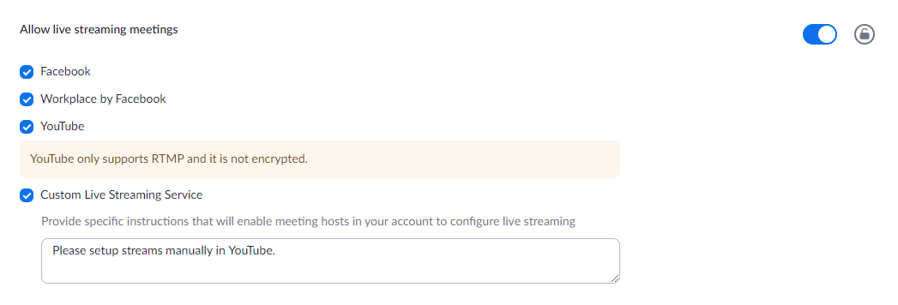.
* For Webinars, you have to enable this under “Admin / Account Managment / Webinar Settings” at the bottom of the page:  
  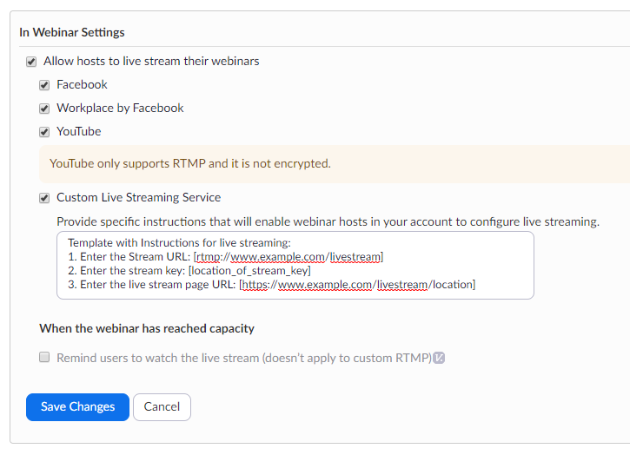

#### Connect Zoom to the YouTube stream

* Open the Zoom meeting scheduler in another tab (on the website, not in the Zoom Client) and edit the meeting
* Go to the bottom of the settings and find the “**Custom Live Streaming Service**” entry

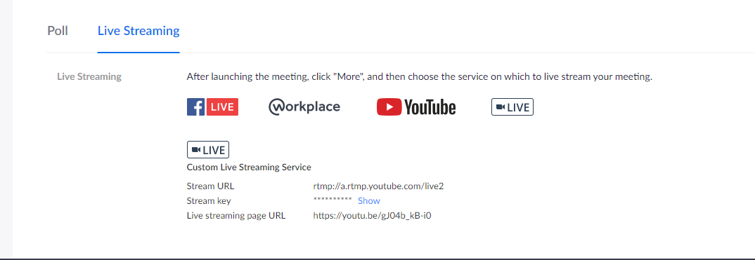

* Click on “Edit” and copy over the YouTube stream details:

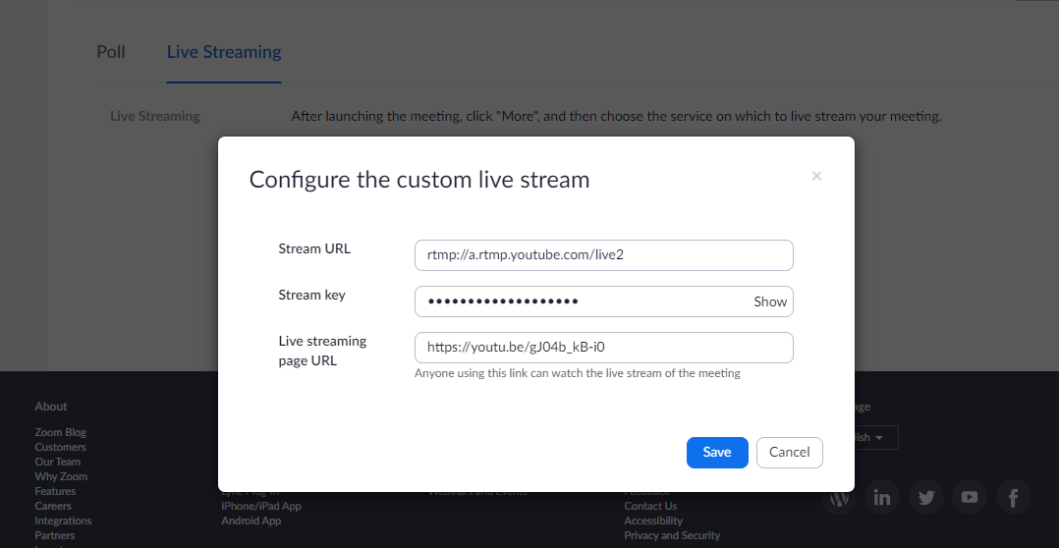

The stream URL and key are available on the YouTube streaming panel.

The Live streaming URL can be had by clicking on the share icon in the YouTube stream page:

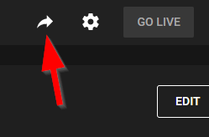

Save the settings in Zoom.

#### Final configuration

* Next, make sure you have the YouTube live chat disabled (unless you want to moderate an additional chat). Click on the gear icon in the upper right of the YouTube stream panel:

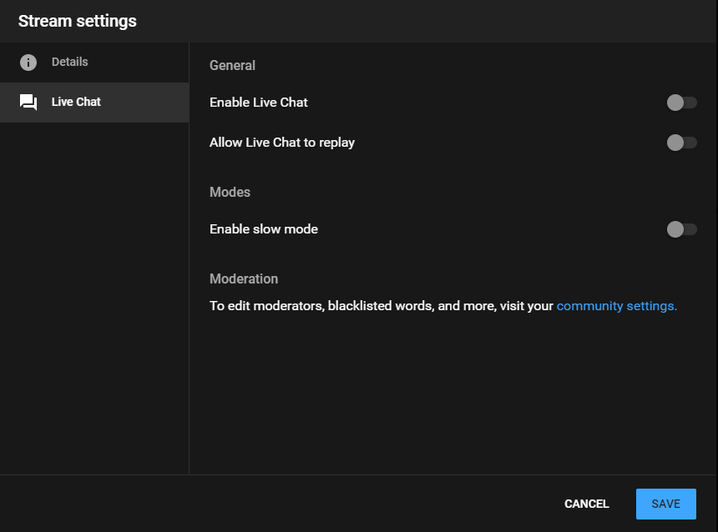

Disable “Enable Live Chat” and “Allow Live Chat to replay”.

That’s it in terms of preparations. There’s more to do closer to the event.

#### Start streaming closer to the event start time

* A few minutes before the meeting should go live, start the Zoom meeting.
* Click on the “More” icon in the meeting window:

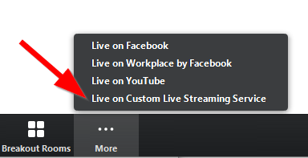

* Click on “Live on Custom Live Streaming Service”.

This will have Zoom connect to YouTube. This takes a few seconds.

* Go back to the YouTube stream panel and wait until the Zoom screen comes up in the upper left of the panel.

Once connected, you will see a red “Go live” button in the upper right.

* Click on “Go live” and check the stream on the YouTube video page (the one you entered in Zoom).

#### At the end of the meeting, don’t forget to stop the stream

* After meeting, stop the streaming to YouTube in Zoom, then click on “End” in the YouTube panel.
* You can trim the video in the YouTube studio as necessary and edit the description, etc. and then publish it.

#### Notes

* Streaming from Zoom to YouTube apparently only works with 720p mode, so you won’t get 1080p resolution. This is important for any live demos etc. to consider, since small characters won’t be readable. The webcam images generally come out fairly dull on YouTube.
* The YouTube stream lags behind the live version in Zoom by a few seconds, even with “Ultra low latency” set. “Normal latency” gives even more lag, up to something like 10-20 seconds. On the plus side, higher latency allows for higher resolution and quality.
* Once a YouTube stream has been stopped, you cannot restart it. Instead you have to create a new stream and copy over the new stream details to the Zoom meeting.
* It is possible to change the streaming settings in Zoom even when the meeting has already started.
* It’s a good idea to also enable local recording of the meeting on the host’s PC and not only rely on the YouTube DVR recording. This serves as backup and provides better resolution, if necessary.
* Zoom adds a fairly large “zoom” watermark logo to the YouTube live streams (in the lower right corner), which then also shows up in YouTube recordings:

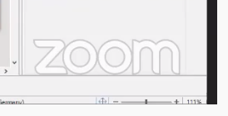

Apparently removing this is not possible. You can only get [another watermark added when using Zoom business accounts](https://support.zoom.us/hc/en-us/articles/360000921326-Custom-Live-Streaming-Watermark) and a smaller version saying “powered by Zoom”:



### Recording Zoom meetings/webinars for later editing

Zoom provides three options for recording videos of your sessions:

1. Local recording
2. Cloud recording
3. YouTube recording

Since these recordings run automatically, there aren’t too many options to choose from and so you are “stuck” with what Zoom gives you for later editing.

The layout of the recordings depends on what you either setup before the meeting (cloud recording), or what the host dynamically selects during the meeting (local and YouTube recording).

#### Recording setups

To stay on the safe side, it’s good to record in at least two ways, with one option being the backup.

It is also possible to use a co-host to play recording editor during the session to take some load off the host. The co-host could then record locally and set the recorded view to whatever looks good during the session, or you could have the co-host instance be run on a separate machine somewhere and just use it for recording purposes.

If you are planning to do more editing of sessions after the event, it’s best to use the Zoom cloud recording option, since this allows you to have the sessions recorded with multiple views simultaneously, which can later be assembled by a video editor to create cut talk videos.

#### Local recording

This can be enabled by the host during the meeting or set to automatically start when the meeting starts.

The local recording is normally only available to the host, but can also be made possible for other participants.

Local recordings are first saved in a Zoom specific format and then converted to MP4 files after the meeting ends. This process can take a longer while and keep the CPU quite busy. Also be careful to watch the process, since at least on Windows, the Zoom client will open the target directory and put focus on this once done -- if you happen to work on something else, there is a chance that you’ll delete files in that directory by hitting the wrong keys.

The recordings will only have one layout, so editing is limited to what the host chose as view during the meeting.

You can configure local recording settings in the Zoom client’s settings under “Recording”:

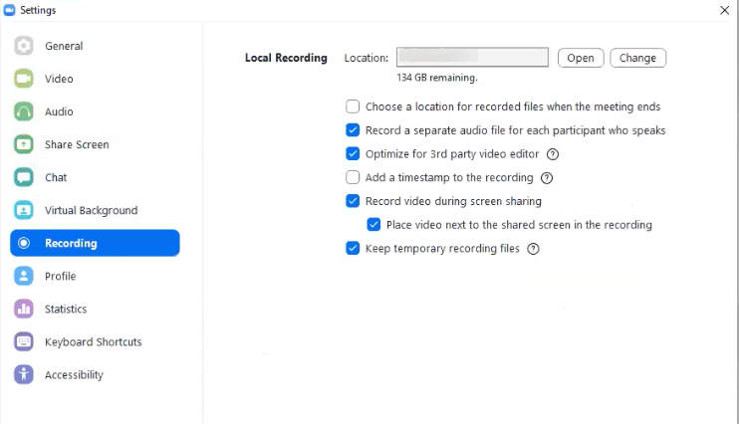

The above is a good choice if you want to have more choices for later editing.

“Record a separate audio file…” causes Zoom to place multiple audio files into an “Audio Record” subfolder of the recording directory, having only individual audio tracks per speaker. The *audio_only.m4a* file in the main directory has the mixed version.

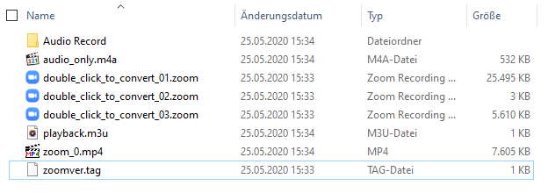

The *zoom_0.mp4* file has the audio and video combined. The double_click_to_convert*.zoom files are the Zoom native recording files. These are normally deleted after converting files to MP4, but can be kept around as a backup using the “Keep temporary recording files” setting.

The “Optimize for 3rd party editing” option is important to have the resulting MP4 seekable.

If you choose “Place video next to share screen”, the recording will put the webcam views next

to the shared screen. This has the advantage of not covering any shared screen content:

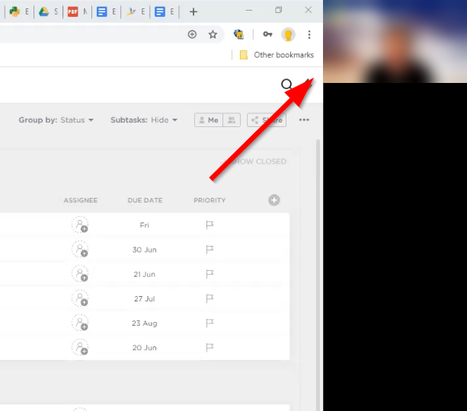

Default is to place the webcam view on top of the screen share in the upper right corner:

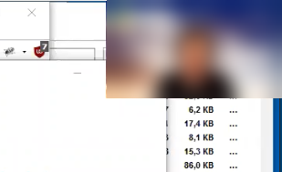

Resources:

* [Zoom Helpdesk on Local Recordings](https://support.zoom.us/hc/en-us/articles/201362473-Local-recording)

#### Cloud recording

Cloud recordings will be recorded on Zoom servers, from which you can then later download the files. They are only available to Pro or higher accounts.

The advantage with these is that you can setup your account or meeting/webinar to record multiple views, so that you can choose the best view when later editing the cut videos. In order for this to happen, you have to enable all possible views in your [Zoom recording setup](https://zoom.us/account/setting?tab=recording):

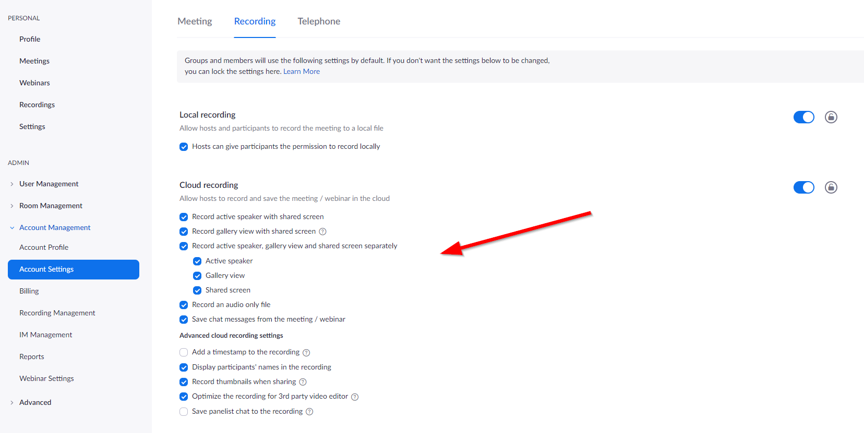

Some time after the sessions have finished, the recordings will be ready for download.

For Zoom meetings you will get these files:

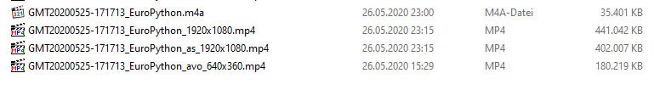

* .m4a - this is the audio only file
* _1920x1080.mp4 - this is the combined screen share + speaker video (full resolution)
* _as_1920x1080.mp4 - this is the screen share only video (full resolution)
* _avo_640x360.mp4 - this is the speaker only video (thumbnail resolution)

For Webinars, some more files are available (you additionally get gallery views):

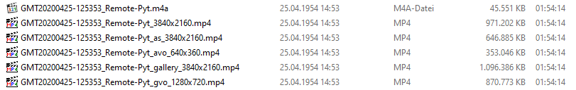

* .m4a - this is the audio only file
* _3840x2160.mp4 - this is the combined screen share + speaker video (full resolution)
* _as_3840x2160.mp4 - this is the screen share only video (full resolution)
* _avo_640x360.mp4 - this is the speaker only video (thumbnail resolution)
* _gallery_3840x2160.mp4 - this is the combined screen share + gallery view video (full resolution)
* _gvo_1280x720.mp4 - this is the gallery view only video (reduced resolution)

Pricing:

* Cloud recording comes with a price: storage is initially limited to around 1GB per Pro account. For a two conference with 3 tracks and multiple view recordings, you will likely need the 100GB add-on for the account (EUR 37 per month).
* Be aware that Zoom seems to allocate the cloud recording add-on to the current month (unless you are booking it on one of the last days of the month). It's a recurring fee, so you’ll have to disable this after use to not pay extra the following months. Fortunately, Zoom will charge the fee pro-rata in the first month, so you only pay for the service you are getting.
* To give you an idea of how much storage space you need for cloud recordings:

A **Zoom meeting or webinar** of one hour with all views recorded will use up around 2-4.5 GB depending on the content that’s shown. More webcams, higher resolution images and faster moving content will create larger files.

For EuroPython 2020, we used 333GB storage space. This included the conference and speaker training recordings. Not included are our internal meetings.

For the conference we only had 360p webcam recordings (at the time Zoom had limited the webcam resolution). The lower range figures provide a good estimate for those recordings. Later in August 2020, this limit was lifted and we could get 1080p resolution for supporting webcams on our business account. This results in larger files in the upper range of the figures we quote above.

Resources:

* [Zoom Helpdesk on Cloud Recordings](https://support.zoom.us/hc/en-us/articles/203741855-Cloud-Recording) (includes pricing information)

Notes:

* It seems that the **recorded screen resolution** depends on who starts the first screen share in a Webinar or Zoom meeting. It could also be the highest resolution used for screensharing during the meeting. We have so far not found any documentation on this on the Zoom website.

While having 4k recordings is nice, the downside is that Zoom puts black bars around screen shares with a lower resolution. Since 1080p is more common than 4k, this could result in a recording where the editor would have to do lots of editing to remove those black bars.

In order to not have to deal with two many resolutions for editing the videos after the event, it’s probably a good idea to ask all hosts and participants to stick to 1080p for screen sharing (if possible).

* It is usually not a good idea to have attendees download these recordings straight from Zoom (before editing them). You can disable this option in the account settings under “Recording”:



* We have had reports from other teams that Zoom Cloud recordings are not always stable and that they even lost recordings. It is therefore advised to download the recordings from the Zoom Cloud soon after they are available (Zoom will send an email to the account owner).

#### Using both cloud and local recording

If the host or a co-host starts recording the session using Cloud Recording, other hosts can no longer record the session locally as additional backup.

The work-around is to assign one or more participants who are not made co-host the recording permission during the meeting (right click on the name in the participant list and enable “Allow recording”).

For this to work, the corresponding setting in the [Zoom account](https://zoom.us/account/setting?tab=recording) has to be enabled:

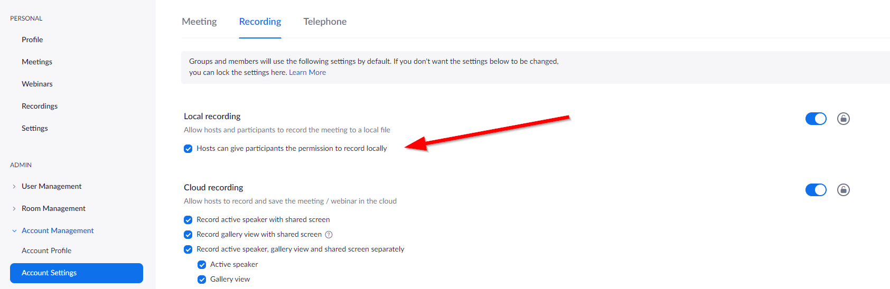

This participant can then run a local recording of the meeting, while the hosts are managing the cloud recording.

The two different recording types are shown in the participant panel:

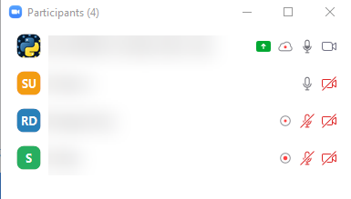

The cloud icons with the red dot means that a cloud recording is running. The circles with the red dot refer to local recordings.

#### YouTube recording

If you stream your session to YouTube, the stream can be setup on YouTube to be automatically recorded (enable the DVR option).

Unfortunately, the YouTube stream coming from Zoom includes a fairly large Zoom watermark logo in the lower right corner:



You will likely not want to have this in the source material you use for editing cut videos, so this is not really a good option, but can serve well as a backup recording nonetheless.

The view recorded on YouTube is the same as selected by the host streaming the event.

#### Breakout rooms and recording

For Zoom meetings, if you choose to use the breakout room and want the discussions from different rooms to be recorded, then you need one person per breakout room to do a local recording. The cloud recording only records the empty main room, even if the host(s) join different breakout rooms. So you need to give permission to multiple people do do a local recording, and spread them across the breakout rooms.

### Addressing Zoom data privacy, security and spamming concerns

There has been a lot of press lately on Zoom privacy and security concerns. Spammers are also a problem when Zoom meetings/webinars are not configured appropriately (the infamous “[Zoom Bombing](https://en.wikipedia.org/wiki/Zoombombing)”).

Many of these concerns can be addressed by choosing settings in the account, which configure Zoom in a way that is more secure. This sometimes includes disabling features, so it’s a trade-off.

These are some recommendations (in no particular order). Most of these settings can be set on a per account, per user and a per meeting/webinar basis. Be sure to choose the right scope when setting these up, since Zoom has lots of settings and things can easily get confusing.

#### Select only the data centers you want Zoom to use for your webinars/meetings in-session data:

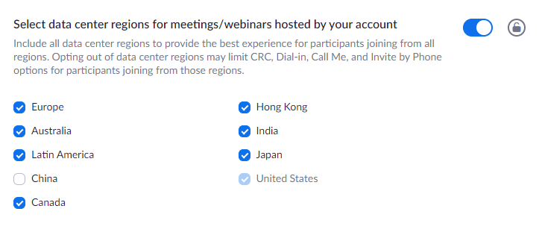

The US cannot be deselected, but it is possible to delects others.

There’s a second setting further down the list for the CDN settings:

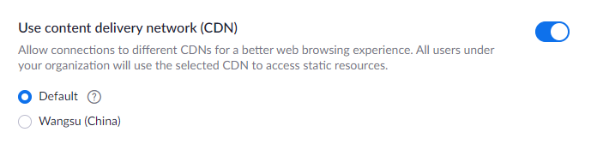

This appears to only be used for browser based Zoom sessions. Details are not really clear. However, you can disable this to prevent use of a CDN, if you like.

#### Configure joining meetings to be safer

Disable “join before host”, so that no one can enter the meeting without the hosting team monitoring actions:



Disable video and audio on start, again, so that this is under control by the host/participants:

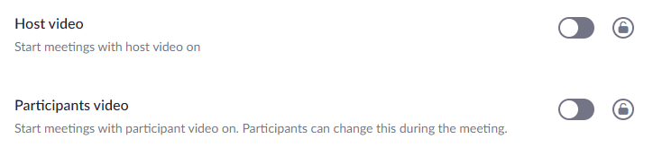

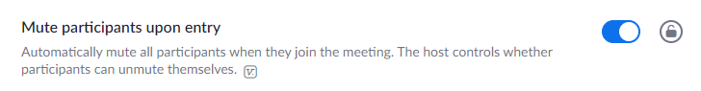

Consider enabling having participants setup a proper Zoom account (which means they have to confirm their email address):

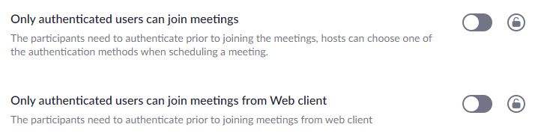

Doing so will limit ad-hoc meetings, but it’s generally safer, if you spread the invite links to a wider audience.

#### Enable passwords everywhere

Enable all “Require a password ....” settings:

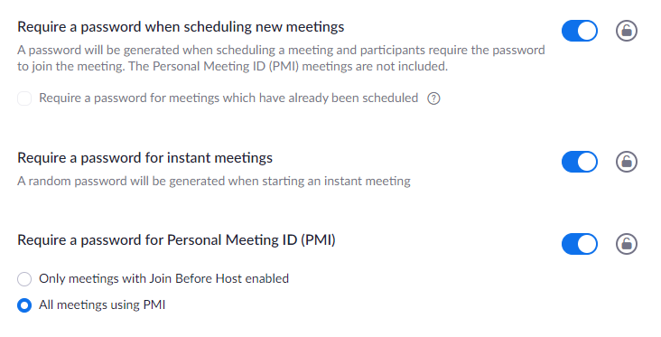

(there are more; see the account settings)

This will prevent people from finding the right number combination of a Zoom invite link to join without authorization (there are Zoom war driving tools out there).

#### Disable chat

The Zoom chat does not have any moderation tools, e.g. it’s not possible to delete messages, so this can be a great source of pain when spammers enter your meeting.

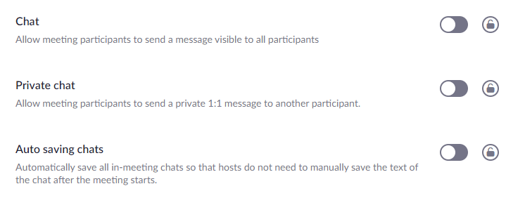

It’s better to use another chat tool with proper moderation tooling, such as Telegram, Slack, Discord, etc.

If you’re running a webinar, you can also use the Q&A feature instead:

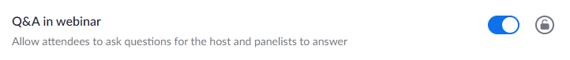

#### Keep control over screen sharing

Either disable this for participants altogether or use a webinar instead of a meeting:

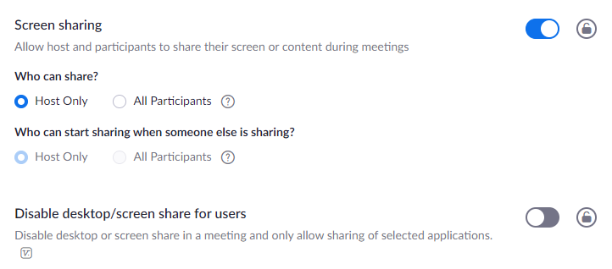

One option to have more control in regular Zoom meetings is to set sharing to “Host only” and then make presenters co-hosts during the sessions.

#### Try to keep control over the Zoom invite links

If you want to advertise free Zoom sessions, it’s usually a good idea to put up some form of authentication or extra step for attendees to follow before they can join. In particular, don’t widely publish the Zoom invite links.

For paid Zoom sessions, spammers are much less likely to be an issue, but you still have the issue that your Zoom invite links and passwords may get leaked to non-paying people and this can again attract spammers.

#### Disable interactive tools such as annotations

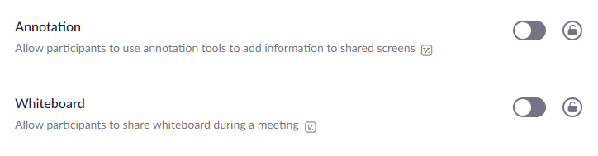

Spammers love to use these tools to disturb meetings and what’s worse: hosts don’t even get to see who is drawing on the slides.

#### Additional protection against spammers

Consider adjusting the following settings. There are up- and downsides to each of them, so what to choose largely depends on your use case.

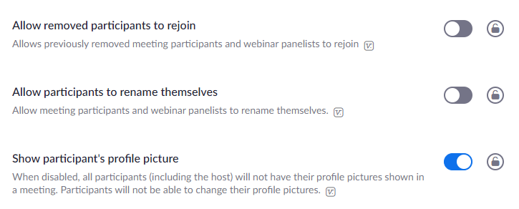

A kicked spammer should not be able to rejoin, but unfortunately, if a regular participant loses connection and wants to rejoin, the settings will also make this impossible.

Participant names can be shown in meetings and they also provide an entry point for spammers.

The same goes for profile pictures, which spammers can set to anything they like.

#### Preventing audio spamming

A problem in Zoom meetings is audio spam. In smaller meetings it is possible to see who is speaking, but in larger ones, this is mostly impossible.

There are a few things you can do as a host, though.

* Quickly hit the “Mute All” button in the participant list:

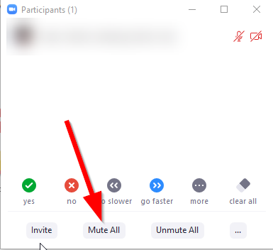

but this will only give you a few seconds of relief, since participants can unmute themselves again...

* It is also possible to mute all participants and disallow them to unmute via this panel:

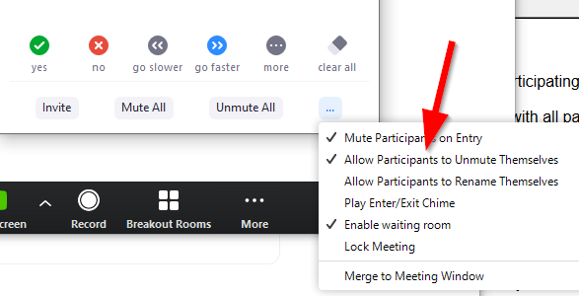

Using this setting you can emulate webinar style setups in Zoom meetings.

#### Enable the waiting room

This is some more work, but it also gives you more control over who joins your meeting. Hosts get notified when people show up in the waiting room.

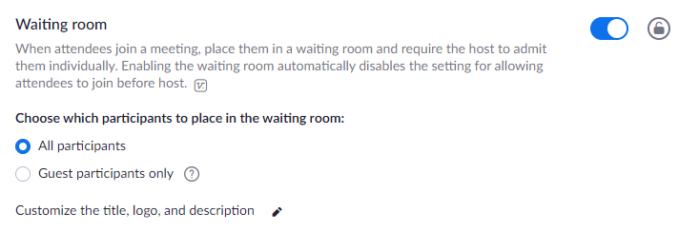

#### Don’t enter full screen when a participant shares their screen

This can be changed in the settings of the Zoom App on -> General -> Share Screen -> untick “Enter full screen when a participant share screen”

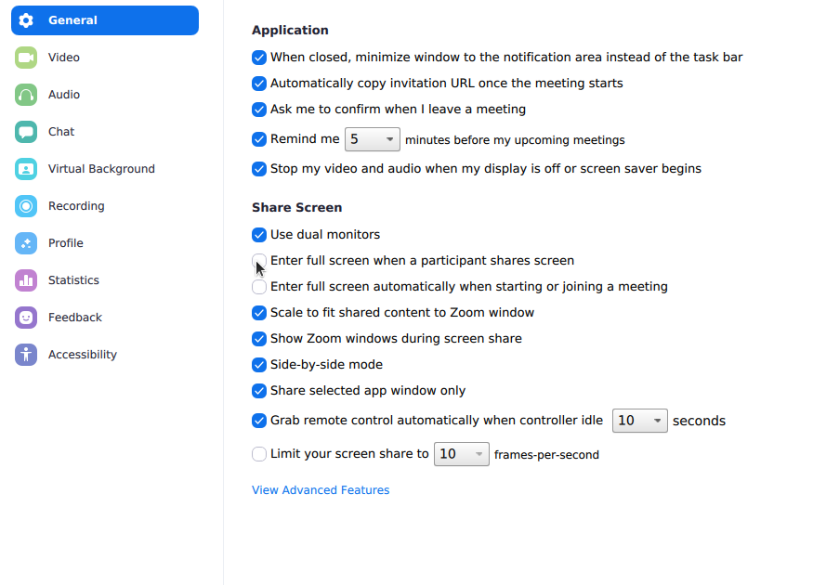

It is better to disable this especially for hosts as they need to juggle many different windows quickly.

#### Preventing profile image spamming

Zoom [introduced a feature](https://blog.zoom.us/wordpress/2020/04/27/its-here-5-things-to-know-about-zoom-5-0/) to disable display of profile pictures with Zoom 5.0 clients for hosts and also as account setting:

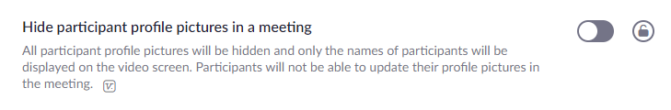

#### Enable peer-to-peer connections for 1-1 meetings

This provides a bit more privacy:

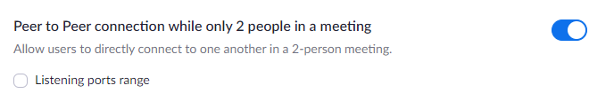

### Change the Zoom client language

The Zoom Client defaults to your locale language settings. If you’d like to change this, the option to do so is a bit hidden, at least on Windows. There’s no option for this in the main Zoom client window in the gear icon dialog, however, it is still possible to change the language.

You have to right click on the icon in the notification bar:

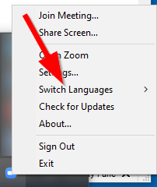

and can then select a different language.

### Improving the speaker webcam recording quality

Zoom records the speaker webcams as 360p video when using cloud recording for Pro accounts, if you enable the “Group HD” setting -- otherwise you only get 180p recordings.

You can improve this quality to 720p and even 1080p with a Zoom Business account, by requesting addition of this feature from [Zoom support](https://support.zoom.us/hc/en-us/articles/201362003) and enabling the higher resolutions in the “Group HD” settings:

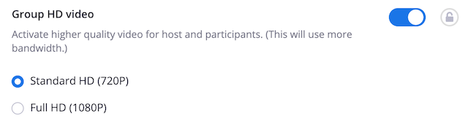

Resources:

* <https://support.zoom.us/hc/en-us/articles/207347086-Group-HD>

### Joining multiple Zoom meetings from the same client

For support staff it may be useful to have them join multiple Zoom meetings at the same. The Zoom client normally only allows to join a single Zoom meeting. You can enable this functionality on Zoom Business accounts by requesting addition from [Zoom support](https://support.zoom.us/hc/en-us/articles/201362003).

Once enabled, you will find an additional setting on your account, which allows turning on the feature:



Resources:

* <https://support.zoom.us/hc/en-us/articles/360001120743-Joining-multiple-meetings-simultaneously-on-desktop>

### Play sounds or music into a Zoom meeting

There are multiple ways this can be done.

#### Share computer audio

You will get the best quality by selecting the “Share computer audio” in the Zoom Share dialog:

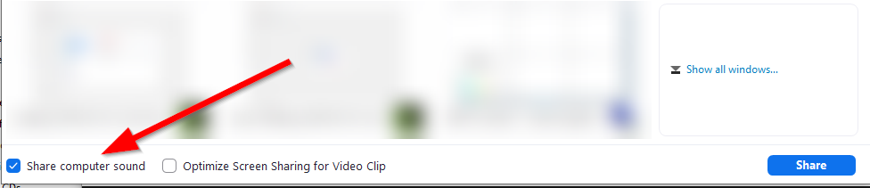

However, this only works if you are allowed to share your screen and normally only one person is allowed to share the screen per meeting (you can turn on multiple screen shares, but attendees will still only see the screen they select to see).

This variant is easy to get going and good for situations where audio is more important and only one person will play the audio into the meeting.

#### Play to Zoom microphone input

The second approach uses the microphone input of Zoom and is more involved, but does have advantages (see the end of the section).

In order to “play” sounds to the microphone input, you will need to setup some audio mixing tools on your machine which provide a virtual microphone as output. The Streaming and Webcam Tools section includes a number of such tools. On Windows, VoiceMeeter works well. On Linux and Macs, JACK seems to do the same job,

Linus + Jack: For how to set jack up on Linux using Qjackctl to achieve this, please see [this guide.](https://docs.google.com/document/d/157pn9INUse4L_rcq9Jt-biI3v0njliRcp5Fj2rTK17c/edit)

Below documents the settings in Windows using Voicemeeter to achieve this.

Once this is working, you have to configure Zoom to accept the input. First, select the virtual microphone in Zoom’s Audio Settings.

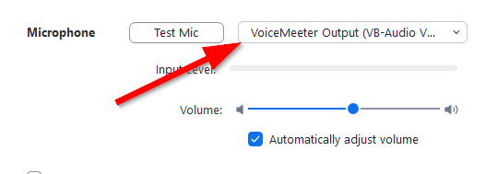

The microphone input of Zoom is normally setup to work with real microphones and has lots of logic in place to prevent echos, background noise, etc. and is generally optimized for speech, not for general purpose sounds or music.

Fortunately, there is a way to configure Zoom to play the original unchanged sound from dedicated microphone inputs. First, you have to enable the button “Turn on Original Sound” in the upper left corner of the Zoom window:

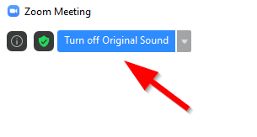

This is done by going into the Zoom client settings, under “Audio” and clicking on the “Advanced” button:

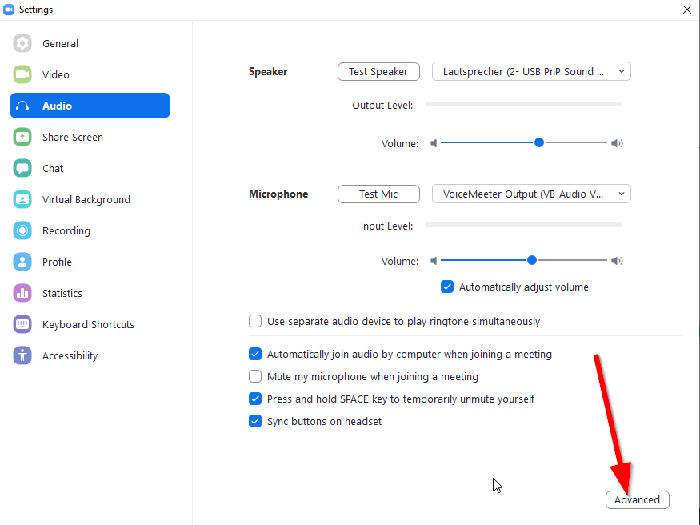

In the dialog, you can then enable the button:

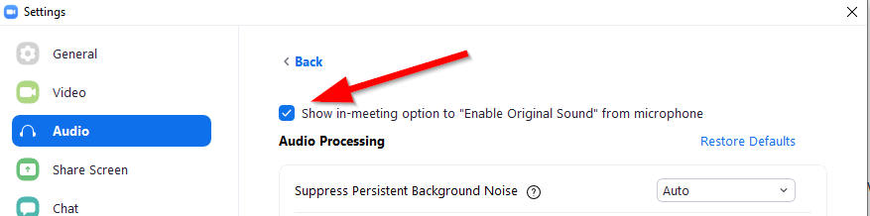

Once enabled, you can click on the drop-down arrow next to the button to have the setting always enabled for certain microphone inputs.

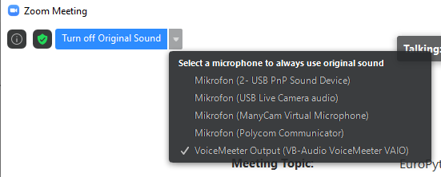

With the button turned on, you can then play sounds or music into your mixer and Zoom will take this as microphone input for the meeting.

More details on the “Original Sound” option:

* <https://support.zoom.us/hc/en-us/articles/115003279466-Enabling-option-to-preserve-original-sound>

The main advantage of this setup, while complex, is that the audio output will be mixed into the general audio stream of Zoom. Other people can still talk, share screens, etc. and there are no implications on permissions, etc. You just have to be able to unmute and talk in the meeting.

Even better: if your mixer is properly setup, you can even continue to use your normal microphone while playing sounds or music.

For Windows, VoiceMeeter Banana (available [here](https://www.vb-audio.com/Voicemeeter/banana.htm)) offers to play sounds (like applause) and music from its own interface into the zoom session while your microphone is live..

Below is a screenshot with an example setup. In it, your microphone & the player both play to the virtual B1 output, which is selected as Microphone input in Zoom. (see red boxes)

The player is also mapped to the A1 hardware output, so you will hear whatever you play, but not your voice. If you want to hear and check yourself, activate A1 on the microphone input. Clicking on the player file name will open a file selector for one directory.

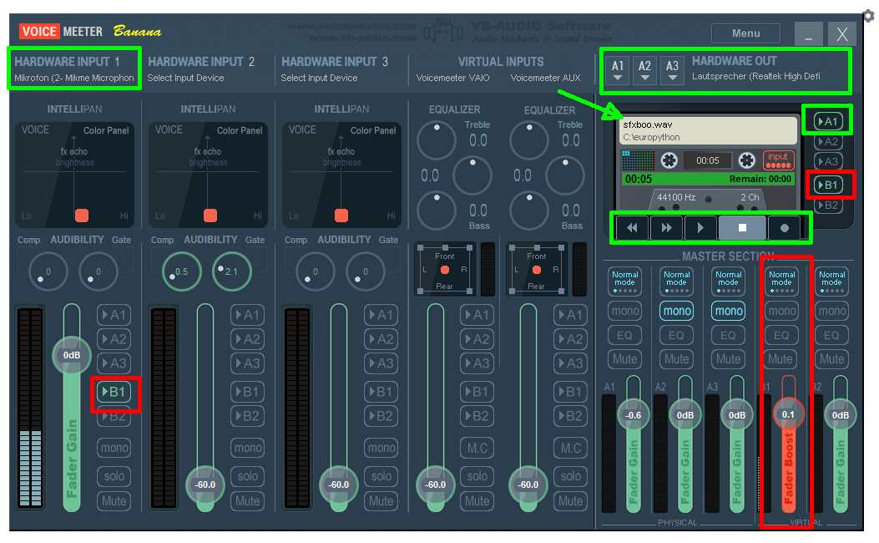

## 

## Discord

### Common topics

These are a few quick links to the [Discord help system](https://support.discordapp.com/hc/en-us).

* [Setting up a server](https://support.discordapp.com/hc/en-us/categories/200404378-Server-Setup)
  + [Managing permissions](https://support.discordapp.com/hc/en-us/articles/206029707)
  + [Server background](https://support.discordapp.com/hc/en-us/articles/360028716472)
  + [Announcement channels](https://support.discordapp.com/hc/en-us/articles/360032008192-Announcement-Channels-) and [Setting up announcement channels](https://support.discordapp.com/hc/en-us/articles/205369668)
  + [Recommended moderation settings](https://support.discordapp.com/hc/en-us/articles/115001987272)
  + [Setting up a terms verification step](https://support.discordapp.com/hc/en-us/community/posts/360042676532-Verification-System)
  + [Getting server verification](https://support.discordapp.com/hc/en-us/articles/360001107231-What-Qualifies-for-Server-Verification-) (currently only available for games and music)
  + [Server invite background and banner setup](https://support.discordapp.com/hc/en-us/articles/360028716472-Server-Banner-Background-Invite-Splash-Image) (the banner is only available for verified servers)
* [Discord UI](https://support.discordapp.com/hc/en-us/categories/200404398-Discord-Interface)
  + [Streaming content from Windows using Go Live](https://support.discordapp.com/hc/en-us/articles/360030714312-Stream-your-game-with-Go-Live-)
  + [Video calls and screen sharing](https://support.discordapp.com/hc/en-us/articles/115000982752-Screen-sharing-Video-Calls) only works in DMs or private group calls

### Accessing user account settings

These are a bit hidden in Discord. In the lower left part of the screen you should see a box like this:



Clicking on the gear will bring up your user account setting.

### Managing privacy and data use

Discord likes to use data or their users and has been criticized for this in the past. Fortunately, you can at least control some of this via user account settings:

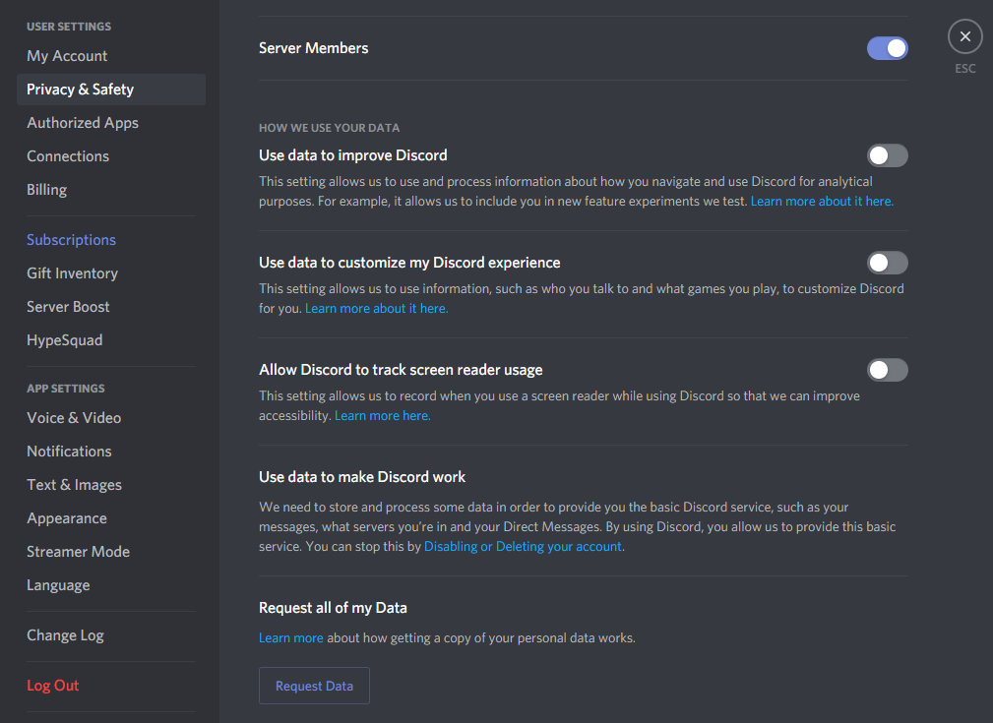

### Streaming a live session

See <https://support.discordapp.com/hc/en-us/articles/360030714312-Stream-your-game-with-Go-Live-> for details on how to set this up.

It only works from the Windows Discord Client and your application must be detected as a game. If you want to stream something else, that’s possible as well, but you have to manually select the application first:

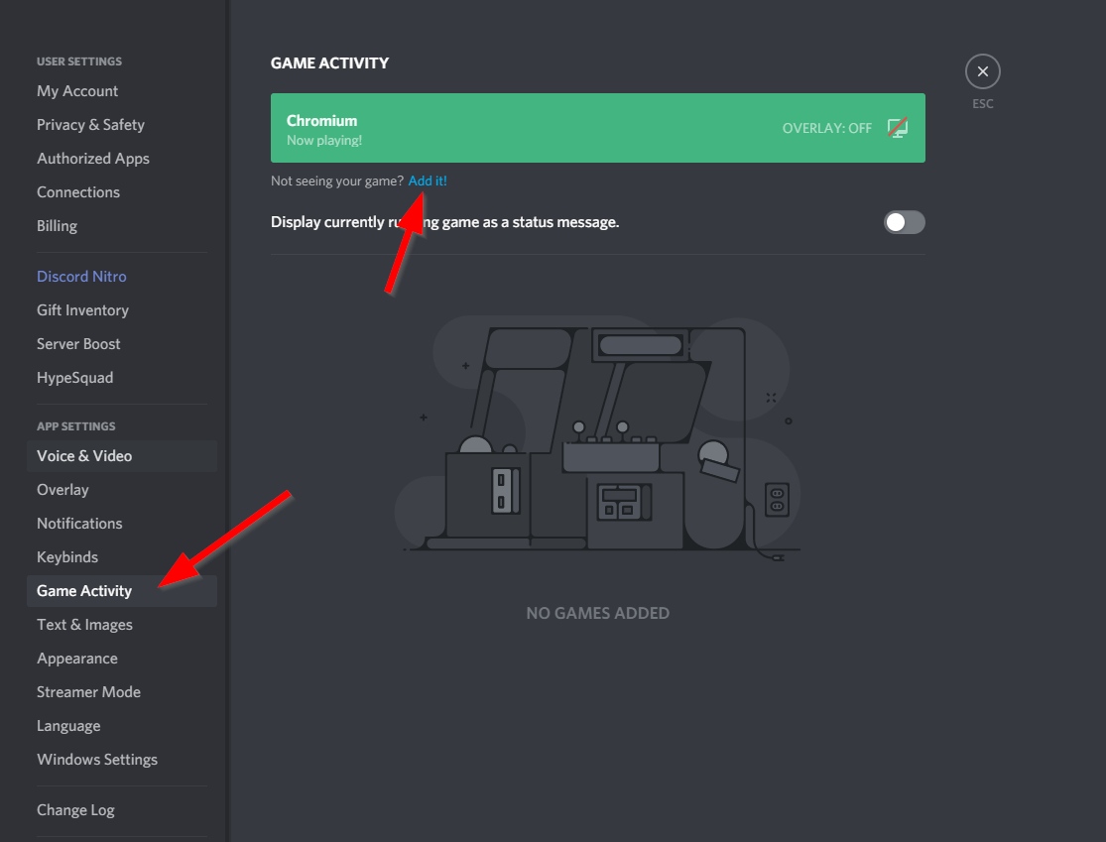

To start streaming, use the new panel that appears once the above has been enabled:

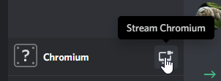

The windows to stream can be changed by clicking on “Change”:

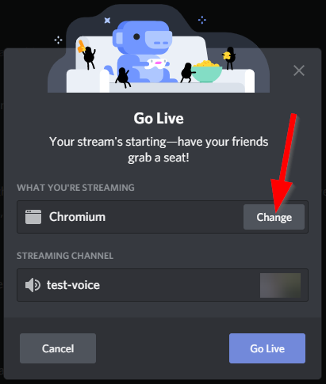

Once you’ve started streaming, you can then invite friends to watch your stream.

### Connecting to a voice channel

In order to connect to a voice channel, simply doubleclick on the channel name:

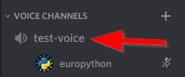

Once connected, a new panel will appear:



To disconnect, click on the disconnect icon:

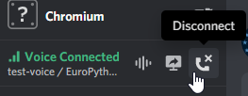

### Creating a welcome channel

Ideally, new server invites should all land in a single channel and only see this one channel until they are promoted to a registered attendee.

This can be configured by first removing all permissions from the @everyone role in the server settings. You may want to leave the “Change nickname” permission on, if you want to enforce clear names on the server.

Next, create a channel “registration-desk” and enable sending messages for @everyone:

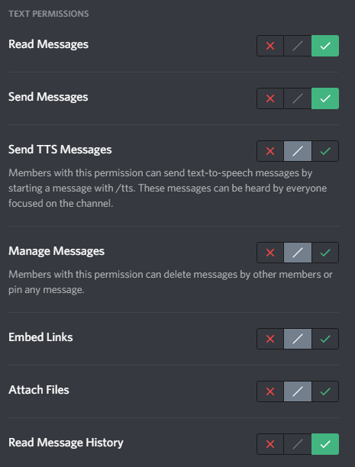

Then create a role “attendee”, which has the same send message rights as above (and perhaps a few more depending on what you want them to be able to do).

All other channels on the server will appear hidden to the new invites and only appear once they are promoted to “attendee”.

Other channels won’t have to be given specific settings for this setup, since all inherit from the server role settings.

### Making a channel private to specific roles

You can either select the roles which should be able to see a channel when creating it as “Private channel”:

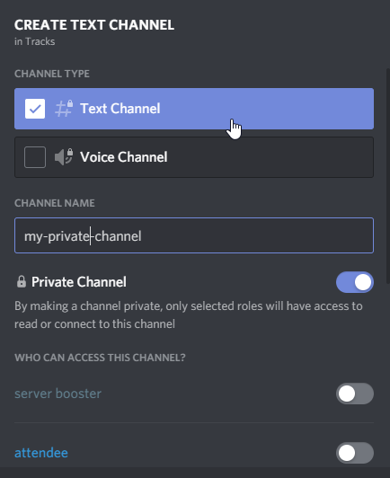

or do this after creation, by explicitly limiting message reads for @everyone in a channel:

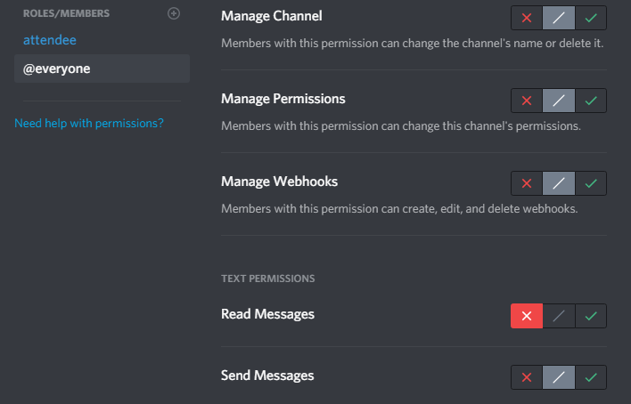

With this setting, the channel will get a small lock symbol attached to it:



In order to allow certain roles to see the channel, you have to add the roles to the channel and give them “Read message” permissions:

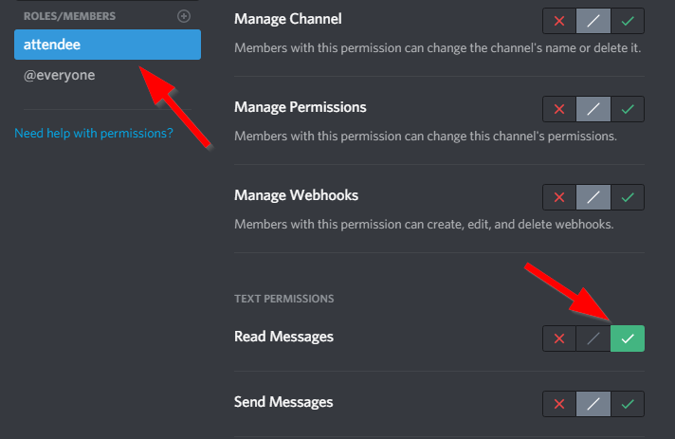

### Disable email notifications

Discord defaults to sending email notifications for e.g. @mentions. This can result in lots of emails, esp. when people use generic role mentions such as @everyone or @attendees, etc.

In order to suppress these email notification, right click on the server, select “Notification Settings” and disable notifications altogether:

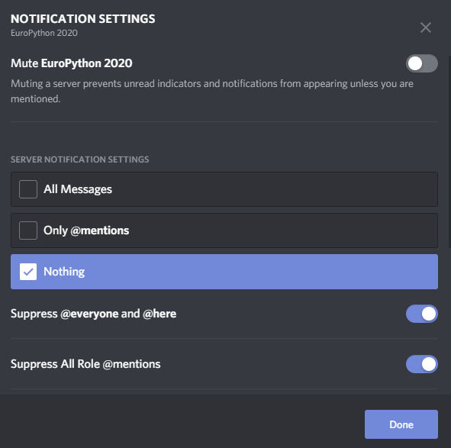

### Managing permissions

Discord allows to set very fine grained permissions on channels and categories.

The permission hierarchy goes like this:

* Server
* Category (group of channels)
* Channel

Channels can be set to sync (inherit) their permissions to the category, but it’s also possible to adjust the settings on a per channel basis.

Permissions can be given to roles (logical groups of members) or individual members. It is possible to set permissions specifically for certain roles by adding more than one role to the permission set in a category or channel.

#### Roles

Roles are defined in the server settings and can be used to give permissions to groups of members, e.g. the organizers, the speakers, the attendees, etc.

The @everyone role is special, since it’s always set on all Discord resources and applies whenever a member is not associated to any other role defined in the resource permissions. The server settings determine the base permissions for @everyone, but they can be overridden on a per resource basis.

There is no inheritance between roles, but it’s usually a good idea to stack them in a hierarchy from lowest permissions (@everyone) to highest (admin).

#### Removing / inheriting / allowing permissions

Discord shows three icons for the permissions on categories and channels, which determine whether permissions are removed, inherited or allowed, compared to the higher level resource (server for categories or category for channels).

Remove a permission for this resource:



Add a permission for this resource:



Inherit permission from the higher level resource:



#### Category / Channel visibility

Visibility of a channel is managed by the “Read Messages” setting. If a member does not have this permission for a channel, the channel is not shown in the UI.

If no channel is visible in a category, the category is hidden as well.